

Come join the fun at the 2023 Bourbon County Fair June 26- July 1. Enclosed in this newsletter are the catalogue listings of exhibit entries in needlework, quilts & sewing, home furnishings, antiques, food preservation, culinary, and agronomy and horticulture along with a flyer of the activities taking place each day of the fair. All of this information and more can be found at https://bourboncountyfairky.com. Do not forget the ky in the link or you will be connected to Bourbon County, Kansas fair!
Pre-fair events include:
June 16 - Walking Horse Show in Sosby Arena
June 17 - Saddle Horse Show in Sosby Arena
June 17 - Bourbon County Fair Pageant at Bourbon
County High School Auditorium
June 24 – Rodeo in Sosby Arena

June 2023

The Bourbon County Fair has always enjoyed the support and participation of the Bourbon County Extension Homemakers. The fairgoers can recall the colorful flags of the different clubs that would decorate the fairgrounds entrance every year. The homemakers have also volunteered to run the fair office and information booth every night of the fair. They help with various inquiries, reunite lost children with their parents, guide people to different events, monitor the exhibits and serve as the main hub of the fair activities.
Another tradition that the homemakers have maintained for over fifty years is hosting a free hospitality booth for both horse shows. The homemakers prepare and donate the food and drinks for all the horse show guests. The guests look forward to their delicious country ham, benedictine and olive nut sandwiches, as well as other classic choices. They also enjoy the variety of homemade cookies that the homemakers bake for them. This tradition is said to have started by homemaker Ernie Allen and Betty Overly more than half a century ago.
The Bourbon County Extension Homemakers have earned a reputation across the state for their generous and friendly refreshments for the horse show exhibitors. They have made Bourbon County famous for their hospitality!
We appreciate the Bourbon County Extension Homemakers for their contributions to all aspects of the Bourbon County Fair over the years!

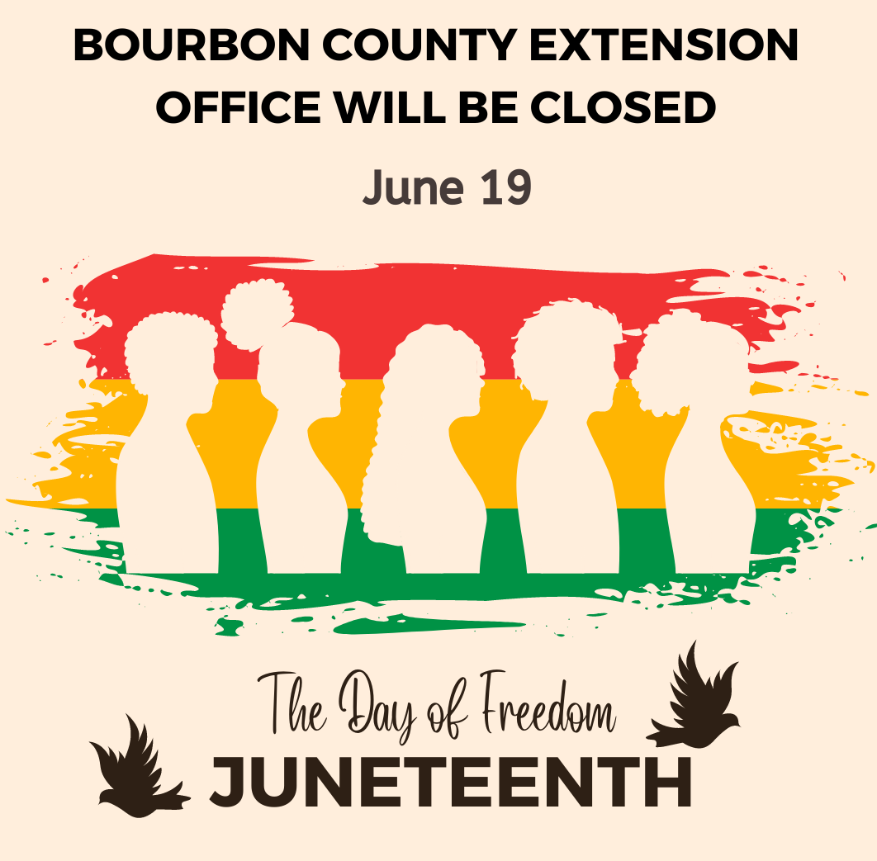


Attention - HOMEMAKERS
BOURBON COUNTY FAIR 2023
Fair time is here! June 26 – July 1
Once again, ALL 2022—2023 Bourbon County Homemaker members
(mailbox/club members)
are eligible for cash awards.
The members who enter the most items in the fair will receive a cash award from the Homemaker Council.
1st Place will receive $75.00
2nd Place will receive $50.00
3rd Place will receive $25.00.
The rules are as follows:
1. You must be a “current” paid Homemaker. (Membership forms will be available at the fair.)
2. A maximum of 5 art exhibits will count.
3. Items must follow the established fair categories. (No categories will be made to fit your entry)
4. When entering exhibits, you must advise the department workers of your Homemaker Club Name or indicate you are a Mailbox member. This information must be handwritten on the back of your entry tag with your name.
These awards will be in addition to the regular Bourbon County Fair Board premiums.
Any further questions on this event, please contact the Bourbon County Extension Office.
Please bring entries to the Bourbon County Fairgrounds
Saturday, June 24th 9:00 am thru 12:00 noon OR Monday, June 26th 8:30 am thru 11:00 am.

Entries will close promptly at 11:00 am for preparation to judge.

Save more at the Store
Think outside the store. Farmers’ markets and farm stands can be a great choice for picking up fresh produce. Visit the Farmers’ Markets and Food Banks directory at PlanEatMove.com/farmersmarketsfood-banks to find a market near you.
• Ask around. Ask friends and family to see where they shop to find great deals! Grocery stores, ethnic markets, dollar stores, retail supercenters, and
wholesale clubs may offer good deals.
• Read the sales flyers. Most of the time sales flyers come out mid-week. Flyers can be found at stores (and their websites), and in newspapers.
• Eat before you shop. Grocery shopping while hungry can lead to impulse buying. It can also lead to food choices that are not healthy. Eat before you go to keep you on task.
• Join your store’s loyalty program. Most stores offer a free loyalty program. Get special offers, coupons, and savings for being a member.
Source: Adapted from USDA, MyPlate

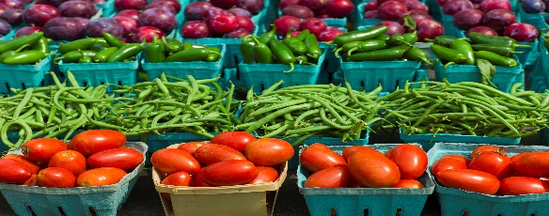

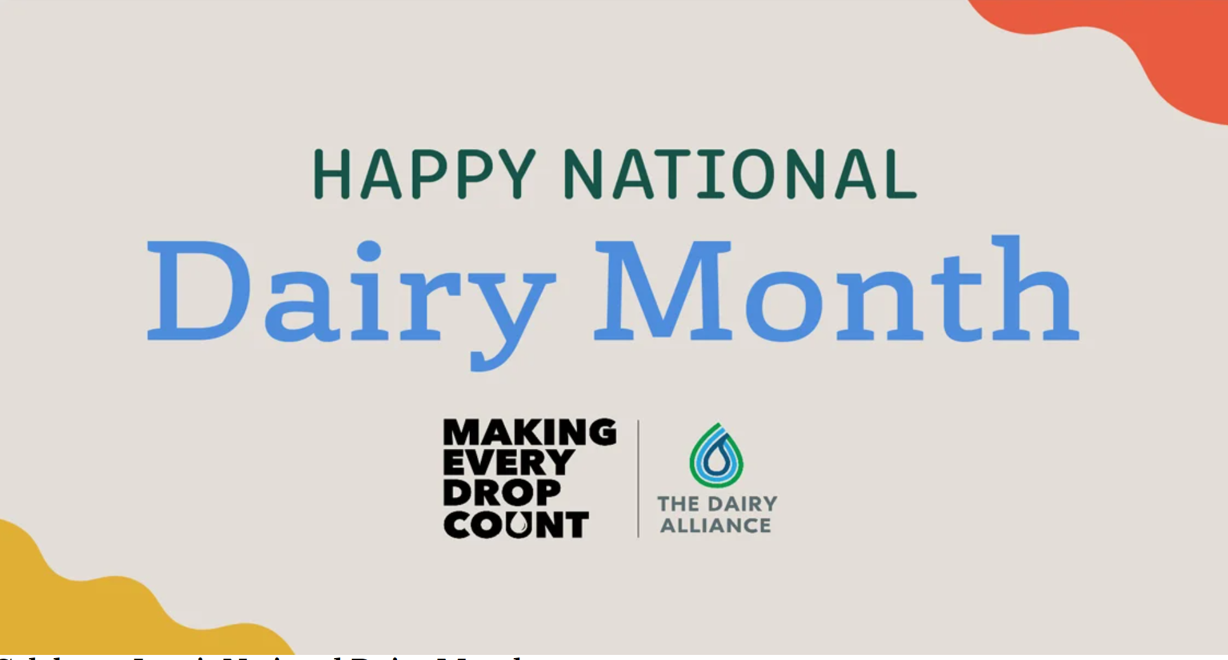

Coming to you on Bourbon County Nutrition Education Facebook page.
If you missed the 1st Friday, it is still available on FB and YouTube.


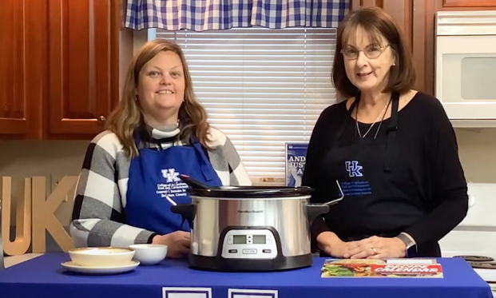
Stop
by the Extension Office
and pick up
your
2023
calendar
to cook
along!

Join us on Bourbon County Nutrition Education Program Facebook page, July 7 to view Kay preparing “Tuscan Chicken and Pasta” or even better - get your ingredients and prepare along with us. Mark your calendar July 7th at noon!






Save the Date

“OUTSIDE the BOX”

June 14 & 15 afternoons..…Assist w/Reports

June 16…….…Horse Show Hospitality Booth
Walking Horse Show
June 16……..……Bourbon Bite Size Learning
Plate It Up Series
June 17…….…Horse Show Hospitality Booth
Saddle Horse Show
June 20………………………Food Preservation
@ Bourbon County
June 22 ……………………..Food Preservation
@ Harrison County
June 24……………………………….…….Rodeo

June 26…………...………………….Fair Entries

June 26-July 1…………..Bourbon County Fair

July 7……….……Bourbon Bite Size Learning
Cooking through the Calendar
July 18-July 20…..……Super Star Chef Camp

July 27……..Bluegrass Area Officer Training

August 17-27……………..Kentucky State Fair

“Bourbon County Homemakers, let’s get started thinking outside the box!”

Thank you Bourbon County Homemakers for such an awesome homemaker year. It was so good to return to “in person” activities and events this year. Homemakers have exceeded expectations in awards, fundraising for scholarship fund as well as general fund and I cannot wait to see out end of the year results for volunteer hours! Homemakers have volunteered with opening school activities, Recipe for Life, Peter Rabbit, Wally Cat Story Walk, Holiday Foods, Adopt a Highway, County Fair and so much more.

2023-24 planning is about to begin. Be sure to share your interests to the council for meeting the needs of our community and for having FUN!
We are proving “we are better together”.
Good job Bourbon County Extension Homemakers!

Mallory Lowe
President Bourbon County
Extension Homemakers





Reporting Volunteer Hours

Volunteering to work at the fair or to prepare items for the fair horse shows? Don’t forget to count you time preparing, shopping, and delivering your food items.

Don’t stop reporting yet.
Volunteer Hours are due to the Extension Office by July 15.

Use the tally method that works best for you.

Keep on recording!



Food Preservation
Pressure and Water Boiling
Canning Workshop

Bourbon County 2023 KEHA State Meeting Highlights

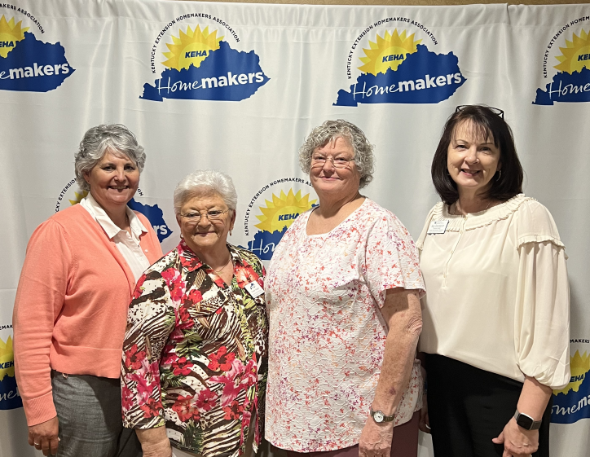
Congratulations to
Jane Linville and
Charlotte Haney
on their first-place awards.

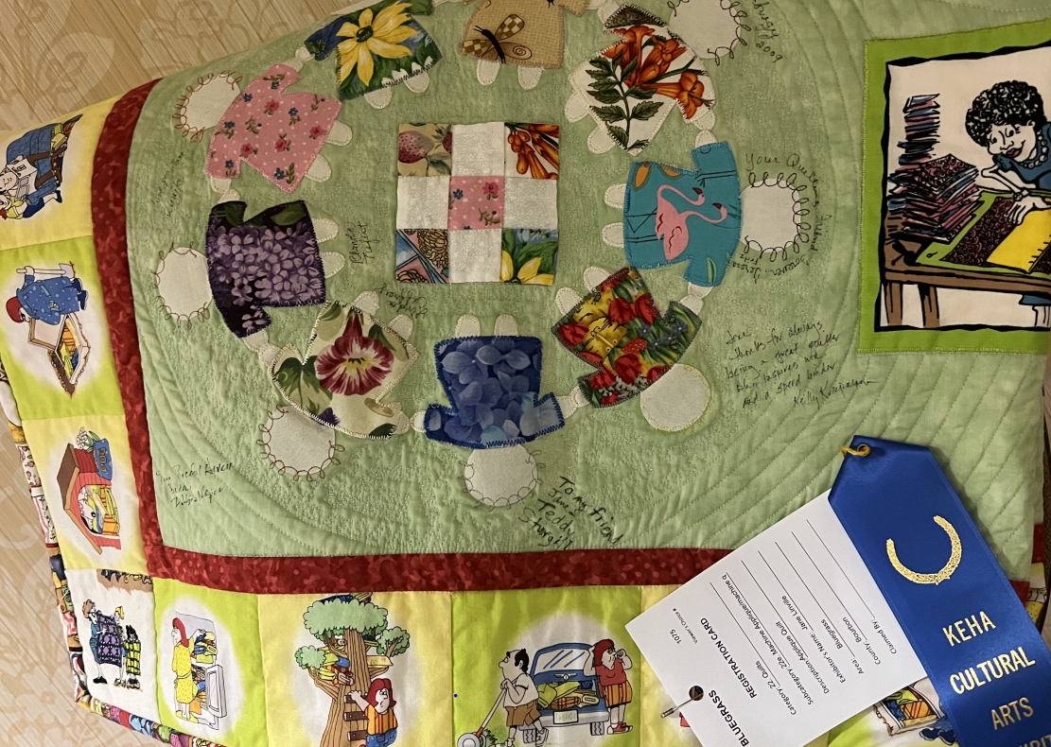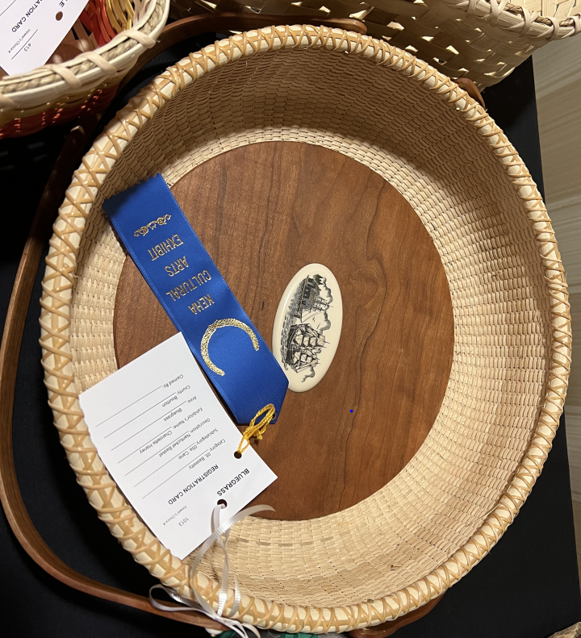
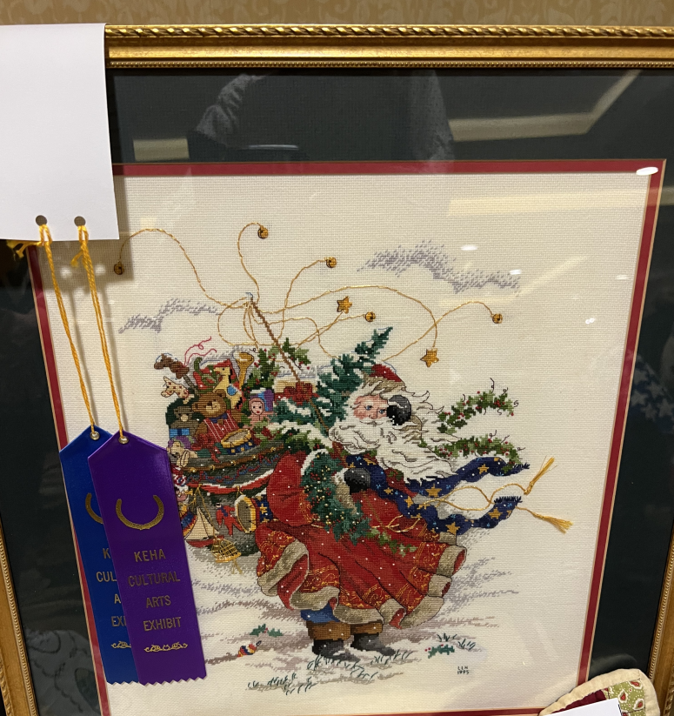

Attendees
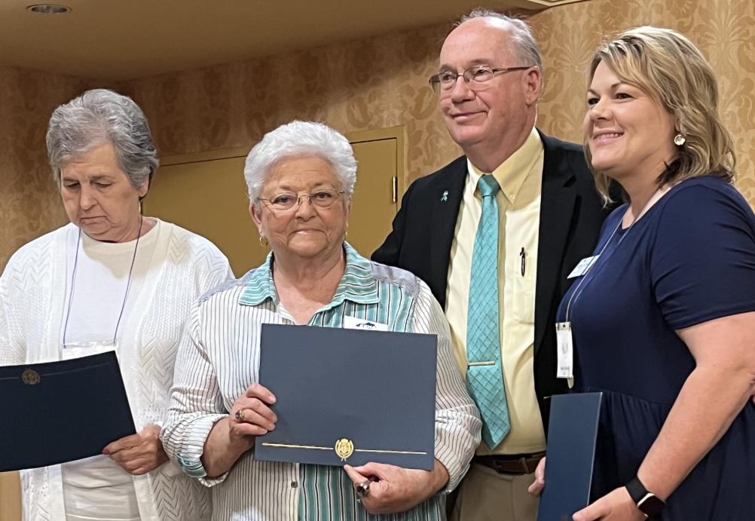
Cultural Arts Winners
Receiving Ovarian Cancer Award
Plan Ahead for Canning Season
Now is the time to start preparing for canning season. It is always a good idea to purchase your supplies early so you are not running around hunting for supplies at the last minute. You can buy canning supplies at many grocery stores, home goods and farm supply stores, hardware stores, big box retailers, and online.
Begin by taking an inventory of your supplies. See what you have on hand and what you need to buy before heading to the store. Inspect gaskets on pressure canners and make sure your racks are in good condition. Now is the perfect time to take your dial gauge canner to the Extension Office and have agents check it for accuracy. Gauges should be checked once a year, and this service is free. Don’t forget to check your jars too. You can reuse canning jars year after year as long as they are not chipped, cracked, or have nicks along the sealing edge. You can also use ring bands over and over if they are not rusted.
When purchasing new jars, buy mason-type jars specifically made for canning. Other types of jars such as storage jars or craft jars are not suitable for canning and may break under the high temperatures of processing. You will also need lids and rings to seal the jars. Experts recommend two-piece lids (flat lid and ring band). If you cannot find two-piece lids, you can buy one-piece lids for use in a boiling water bath canner. Do not use one-piece lids in a pressure canner.
Get more information on canning, including research-based recipes, by contacting the Bourbon County Extension Office.
Source: Annhall Norris, Food Preservation and Food Safety Extension Specialist

Eating Over the Rainbow: A Fruit & Veggie a Day Challenge
a

How often do you eat fruits and vegetables? A recent report showed many Kentucky children ages 1 through 5 years old do not eat at least one fruit or vegetable each day. There are many reasons why children or other family members do not eat fruit or vegetables daily. They might not have transportation to food stores that sell fruit and vegetables. The price of fresh produce might be too high for a family’s budget for food. Children might not be comfortable with eating or like the taste of fruit and vegetables.
No matter the reason, there is help available. Your local health department can give you information about the Women, Infants, and Children (WIC) program. WIC provides nutritious foods as well as nutrition counseling, breastfeeding support, education, and referrals to health-care services for pregnant, breastfeeding, postpartum women, infants, and children up to age 5. Anyone can complete applications for the Kentucky Supplemental Nutrition Assistance Program (SNAP) online, over the phone, or in person at the local Department for Community Based Services. SNAP increases a person’s food buying power. Local farmers’ markets and other retail stores often take part in the Kentucky Double Dollars program. This program gives vouchers or tokens to buy more Kentucky-grown products. Reach out to your local Extension office for support in connecting with any of these programs.
Making food fun is a way to encourage children to try new foods, especially fruit and vegetables. We invite your family to join our Eating Over the Rainbow challenge to eat at least one fruit and vegetable each day, for one week. Signing up with your local Extension office will get you looped into activities to do with children and tips for encouraging children to give fruit and vegetables a chance. We hope you’ll join us in taking action to help children try at least one fruit and vegetable each day so they can explore, grow strong, learn, and play!
Source: Courtney Luecking, Extension Specialist for Nutrition and Health
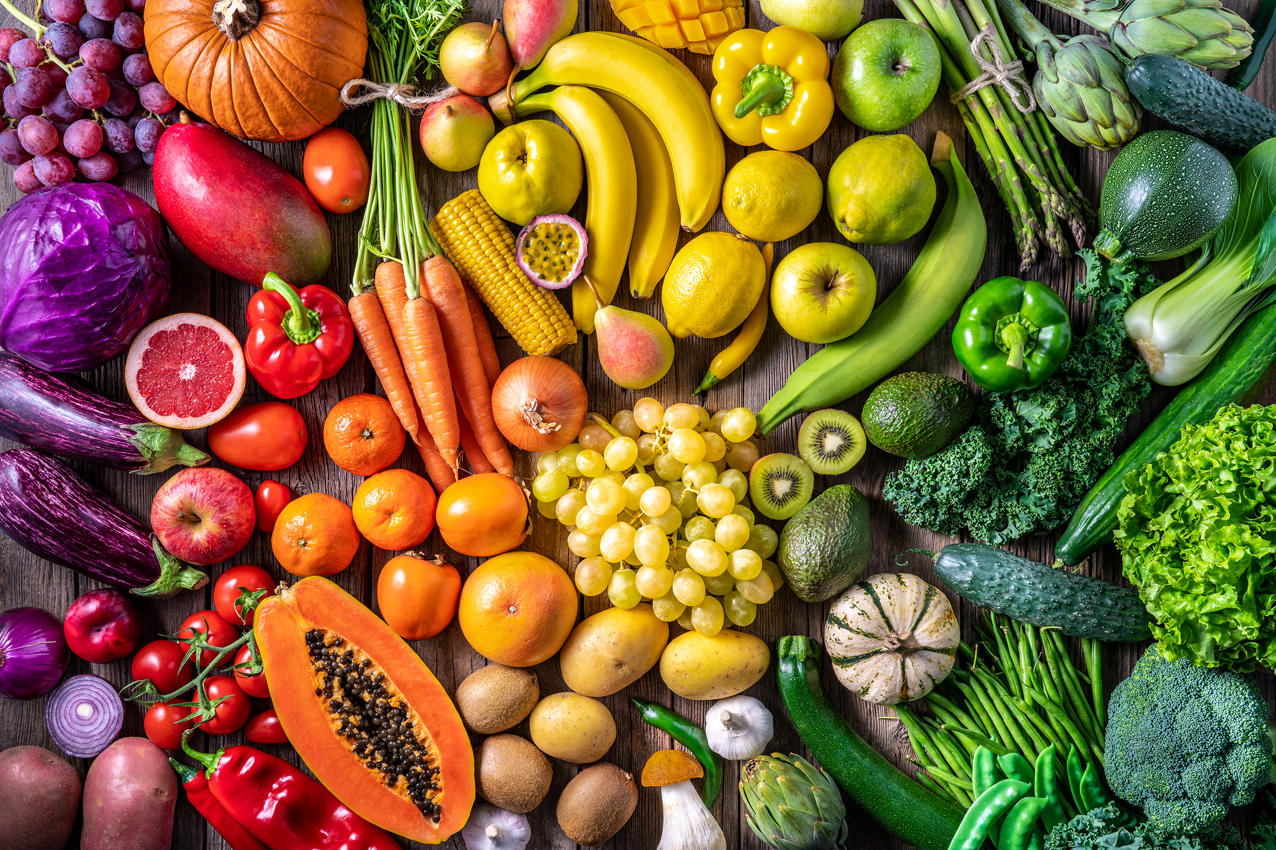



POP Club is back! Come join the fun.


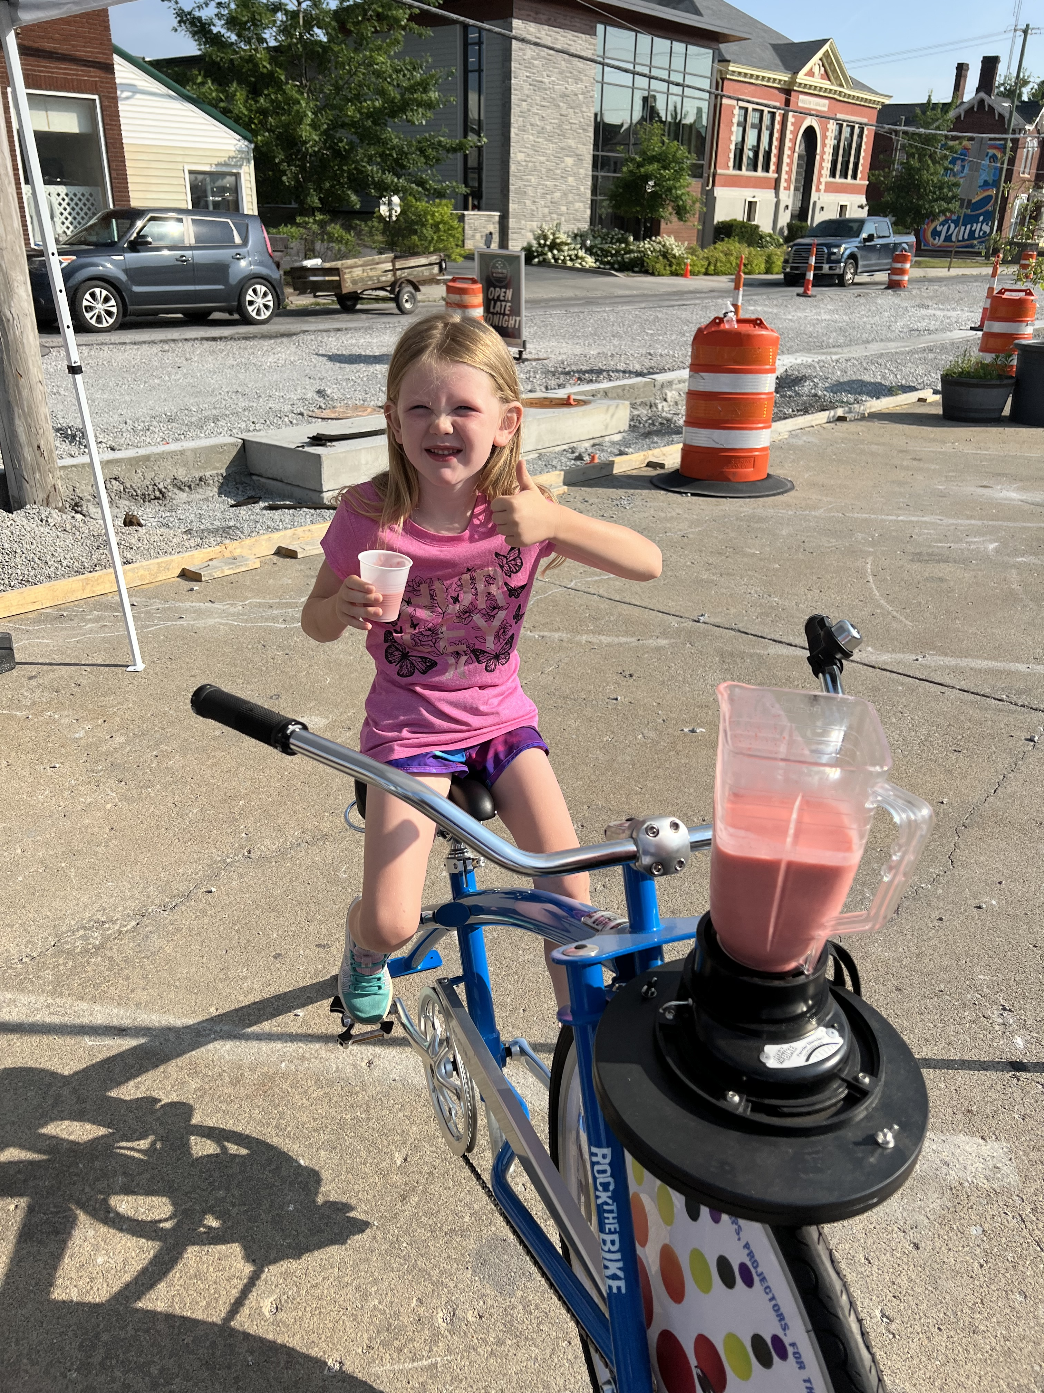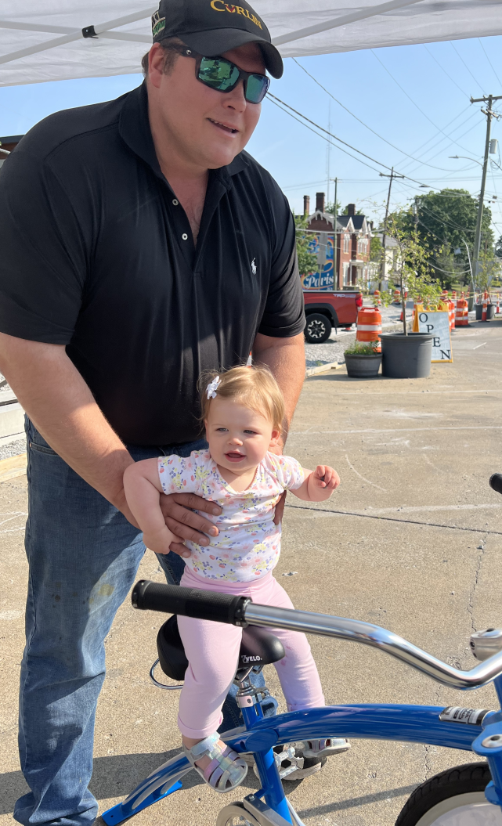
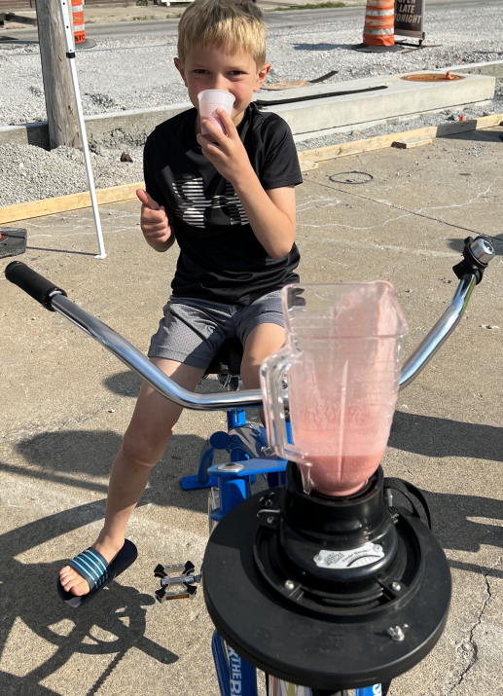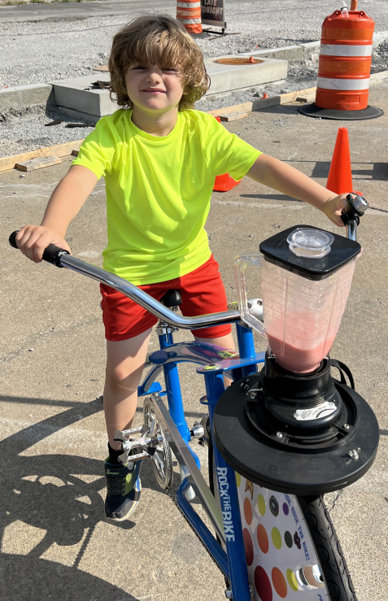
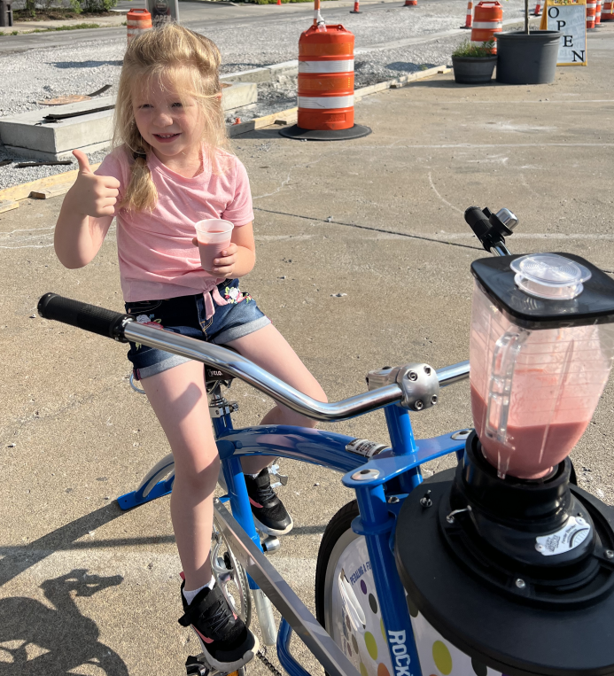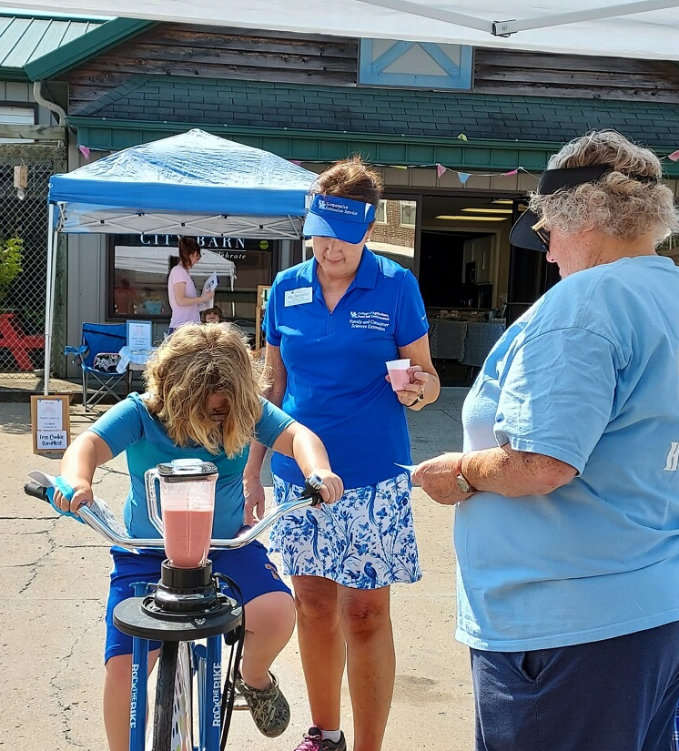

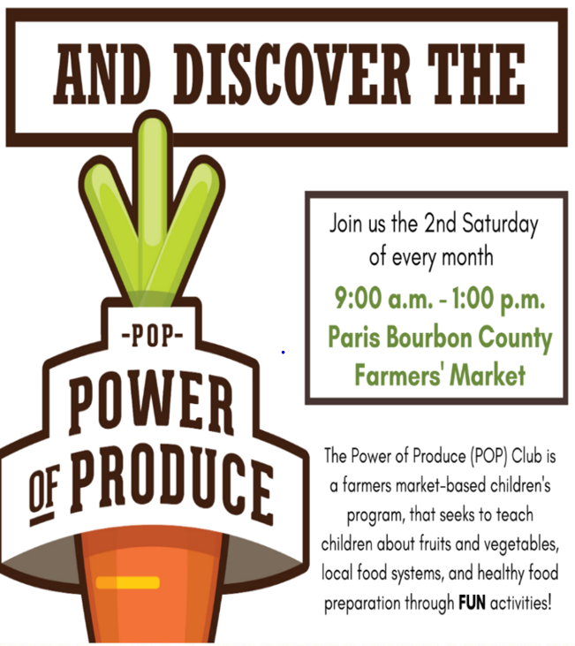
Join us the 1st Saturday
of every month
Fun for the whole family!

