Page 1

Agent Notes




Hello, fellow gardeners and hort producers! I hope you are enjoying the bounty of the local growing season so far. It's been a good year for our crops, despite some challenges along the way. Let me give you a brief summary of what's been happening in our county.

You may remember that June was cooler than usual, which slowed down the growth of some plants. But it also helped us avoid heat stress and sunburn on our tender greens and herbs. Then we had some dry spells in early summer, which made us worry about watering our gardens. But the upside was that we had less problems early with fungal and bacterial diseases on our fruits and vegetables.

Overall, we've had a good growing season so far, and we have plenty of delicious produce to enjoy. And the best part is, we have more choices than ever for locally grown fruits and vegetables in Bourbon County. Thanks to the hard work and dedication of our farmers, we have more farm-based retail outlets where we can buy fresh, healthy and tasty food. Whether it's a roadside stand, a farmers market, a CSA box or a farm store, there's something for everyone.

And speaking of hard work and dedication, I want to congratulate the 16 residents who completed the classroom content portion of the Master Gardener program. They learned a lot about horticulture, from soil science to pest
management to plant identification. Now they are applying their knowledge and skills to various community-based projects, such as beautifying public spaces, educating school children, helping food banks and more. They are making a difference in our county and beyond.

So let's celebrate the local growing season and all the people who make it possible. And let's keep supporting our farmers and gardeners who provide us with food, beauty and joy. Happy harvesting!





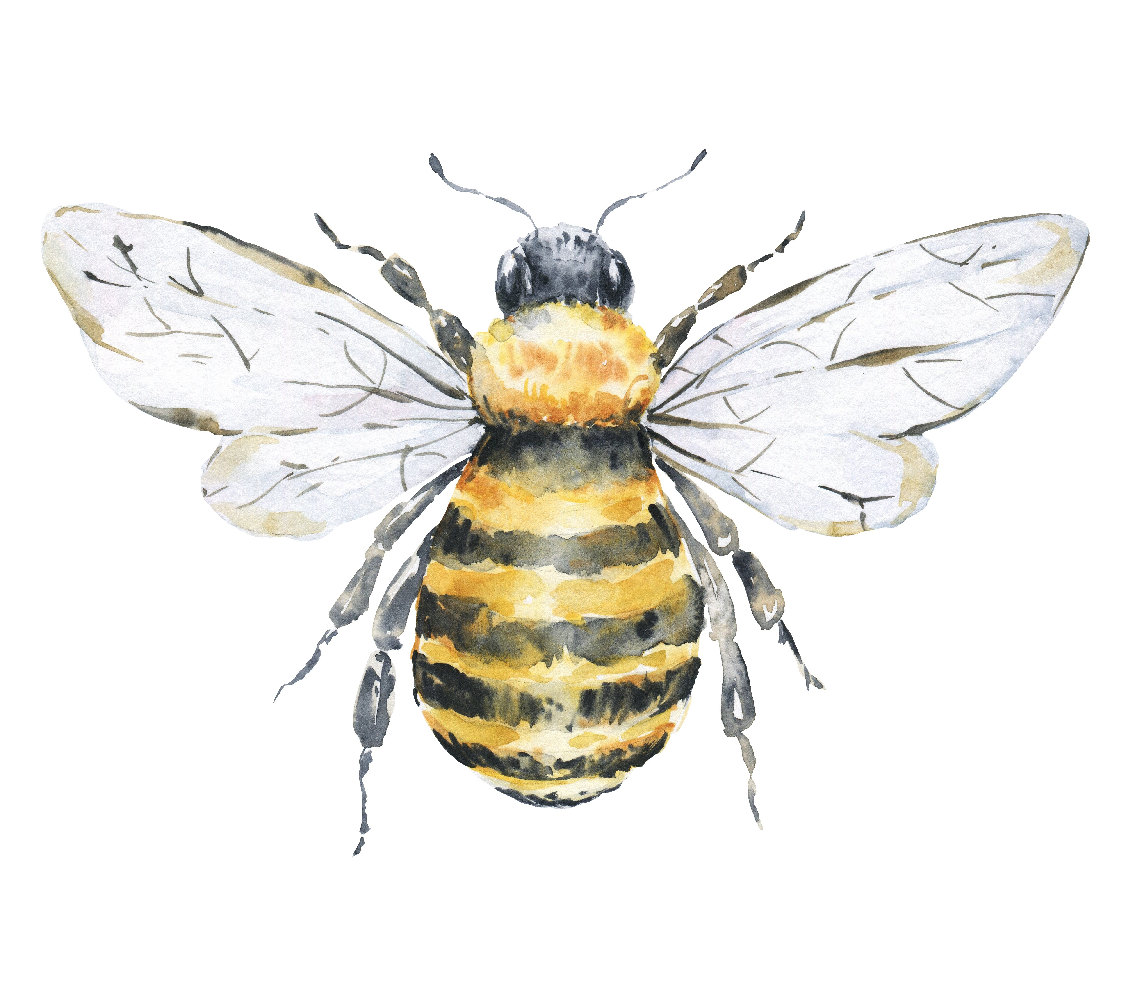
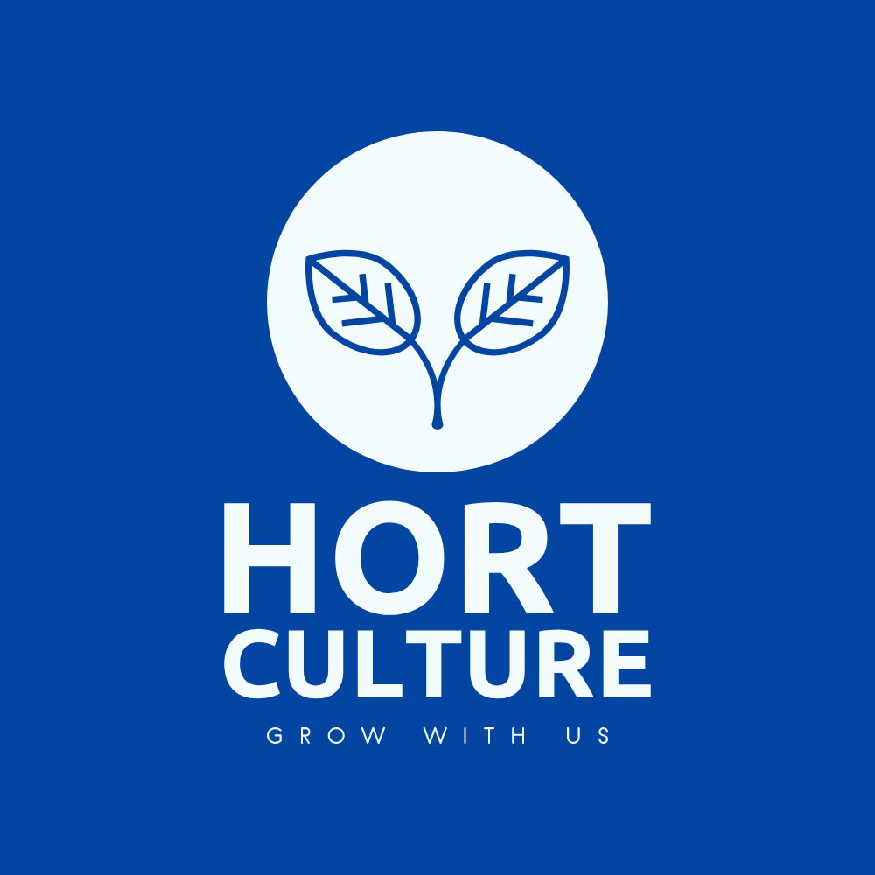
Weekly Local Podcast Now Available!

If you are passionate about plants, gardening, and production horticulture, you will love our new Hort Culture podcast. This podcast features interviews with experts, tips and tricks, and stories from people who share your love of all things green. Whether you are a home gardener or a commercial producer, you will find something to inspire you and help you grow your skills and knowledge. Tune in every week to learn more about the fascinating culture of horticulture!

Follow Link or scan QR code on right:
bit.ly/3Onxs2J

GARDENING TO DO LIST FOR AUGUST

For many gardeners the month of August begins the downhill slide into oﬀ season. Warm climate gardeners have a second chance, but some don’t have a second wind after summer’s heat. Your garden is hardier than you think, and there are plenty of gardening tasks for August that will keep your flower and vegetable gardens going longer as well as opportunities to get a head start on next year’s garden plans.

Here’s a Garden-To-Do List for the month of August:

- Seed a fall crop of peas and spinach and
- Prune summer flowering shrubs as the flowers fade.
- Trim and feed hanging baskets to prolong their beauty.
- Take pictures of your garden at peak. Take pictures of container combinations you’d like to repeat.
- Make sure the cold frame is ready to go.
- Begin dividing perennials. Start with bearded iris.
- Pot up perennial divisions for spring plant swaps. Sink the pots into the ground this fall and they’ll be one less chore in the spring.
- Plant trees, shrubs and perennials now, so they can take root, and keep them well watered.
- Get your fall-blooming crocus and colchicum planted so they’ll bloom on time.

keep harvesting. There’s always something

to make with zucchini.
- Pick herbs for fresh use and for drying. Harvesting will keep them growing longer.
- Order spring bulbs for planting and forcing.
- Check that your mulch hasn’t decomposed and add more as needed.
- Spread a mid-season layer of compost or manure.
- Keep deadheading and harvesting.
- Leave some annual seeds to self-sow.
- Start saving seeds and take cuttings.
- Remove any diseased foliage now, so it doesn’t get lost in the fall leaves.
- Cut back the foliage of early bloomers like Brunnera and hardy geraniums, to revitalize the plants.

Then sit back and enjoy all you’ve accomplished!
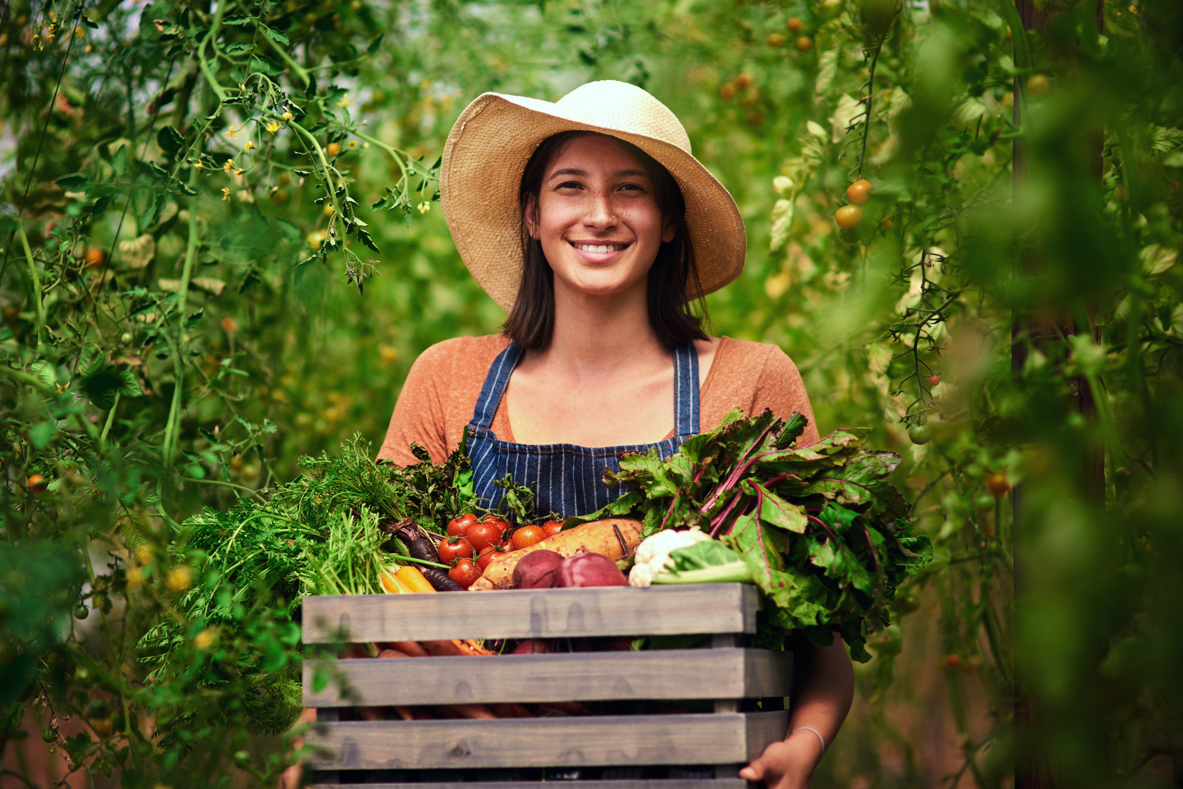


Did you know that every county in Kentucky is assigned a private lands biologist. A Kentucky private lands wildlife biologist is a professional who works with landowners and other stakeholders to conserve and enhance wildlife habitat on private properties. They provide technical assistance, planning, and management recommendations to help landowners achieve their wildlife goals and benefit the environment. They also collaborate with other agencies and organizations to implement conservation programs and projects on private lands.
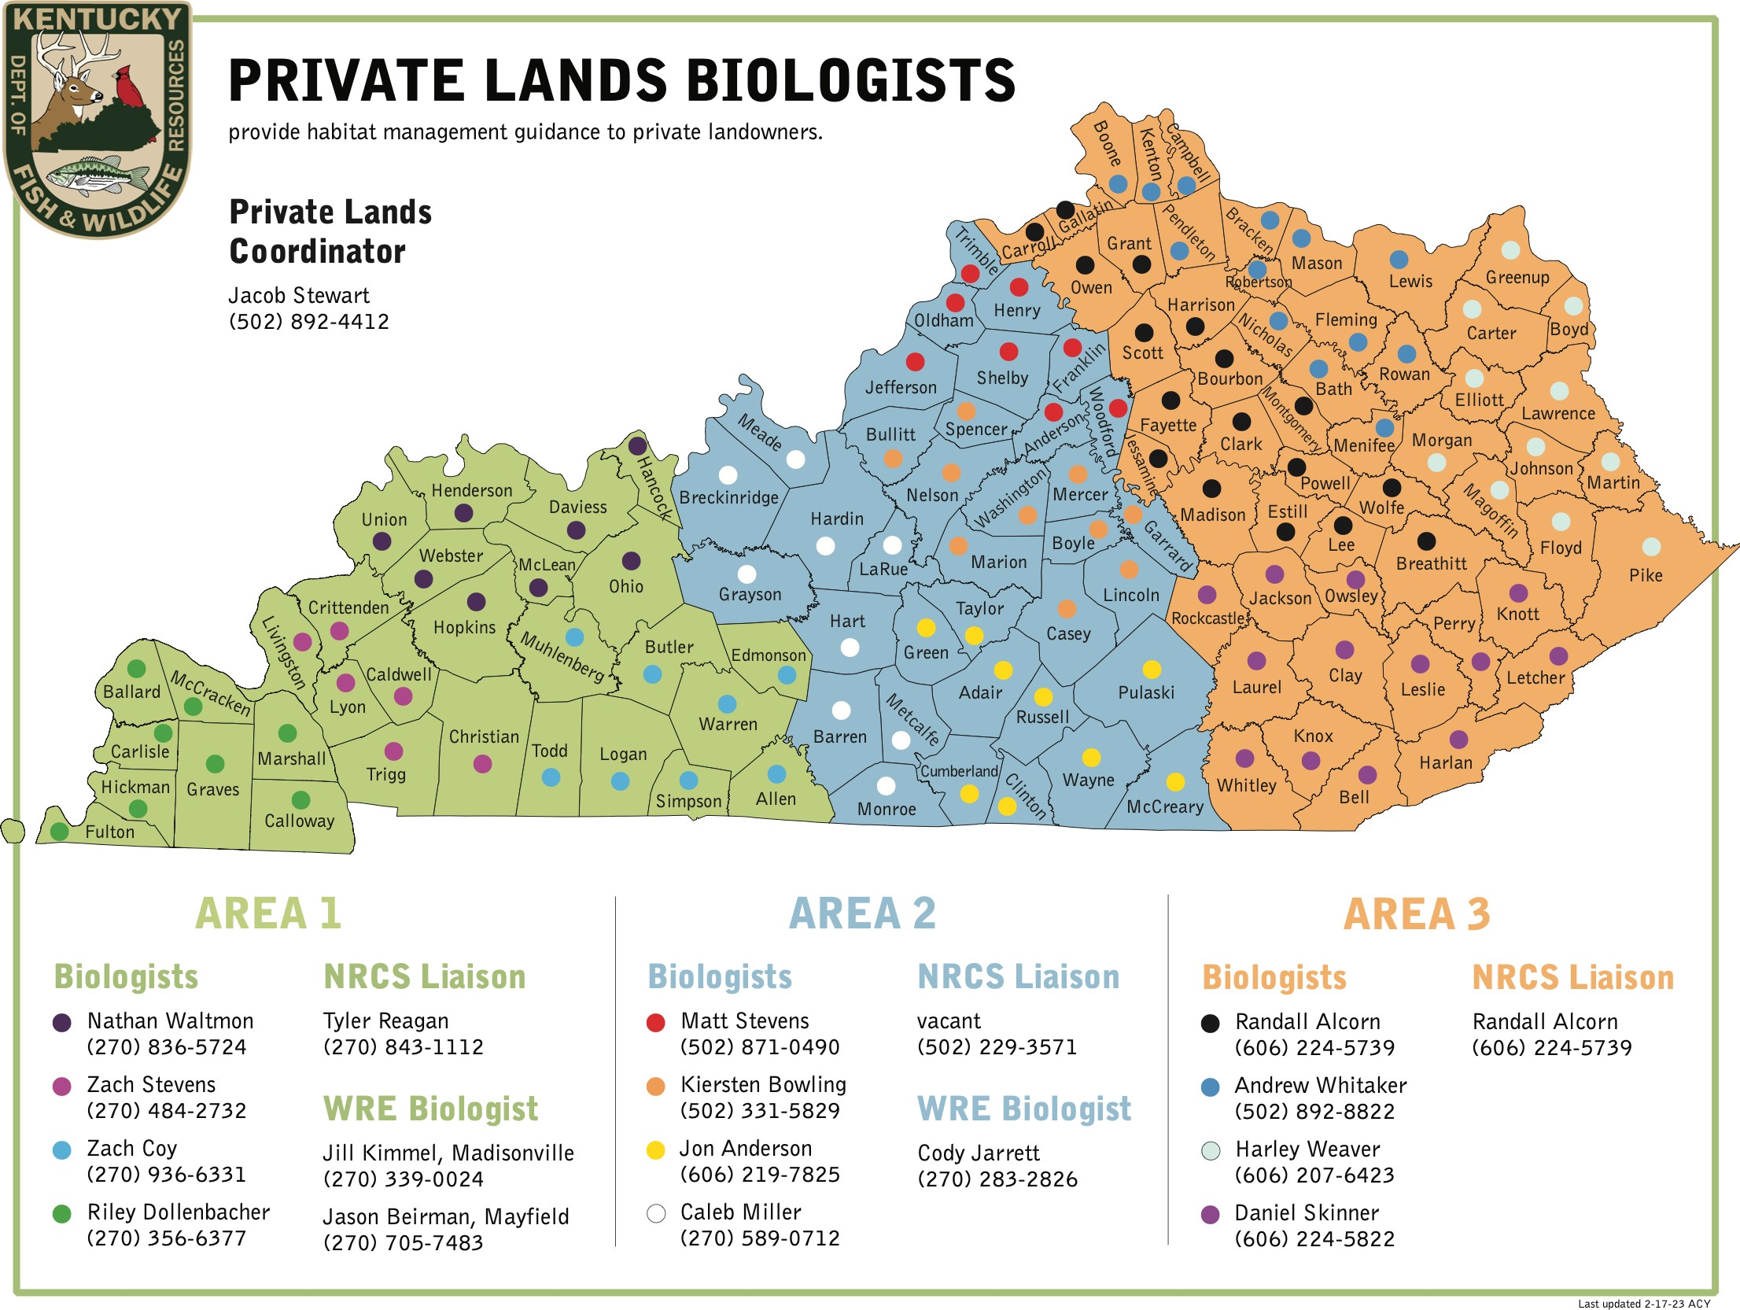



Check out our Horticulture YouTube channel for lots of great video content!
Link: https://bit.ly/3Q6YVHu or QR code below




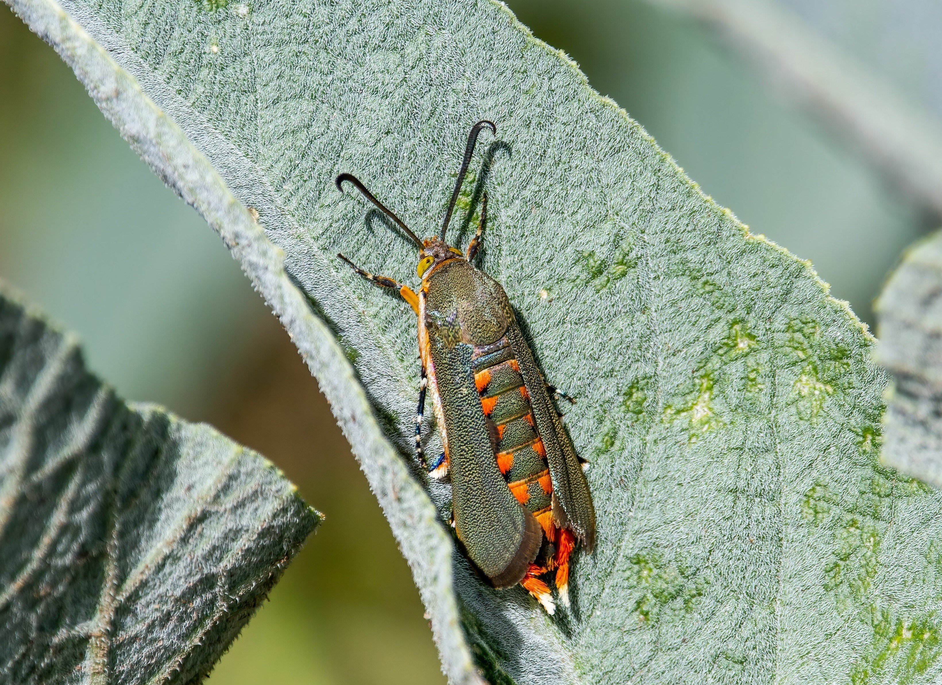
Garden Notes
If you love growing squash in your garden, you may have encountered the squash vine borer, a pest that can cause your plants to wilt and die. Fortunately, there are some squash varieties that are more resistant to this pest, such as butternut squash and cocozelle squash. You can also monitor your plants for signs of borer activity, such as sawdust-like frass near the base of the stem, and apply insecticides to control newly hatching larvae. For more information, visit https://entomology.ca.uky.edu/ef314

Squash Vine Borer Moth

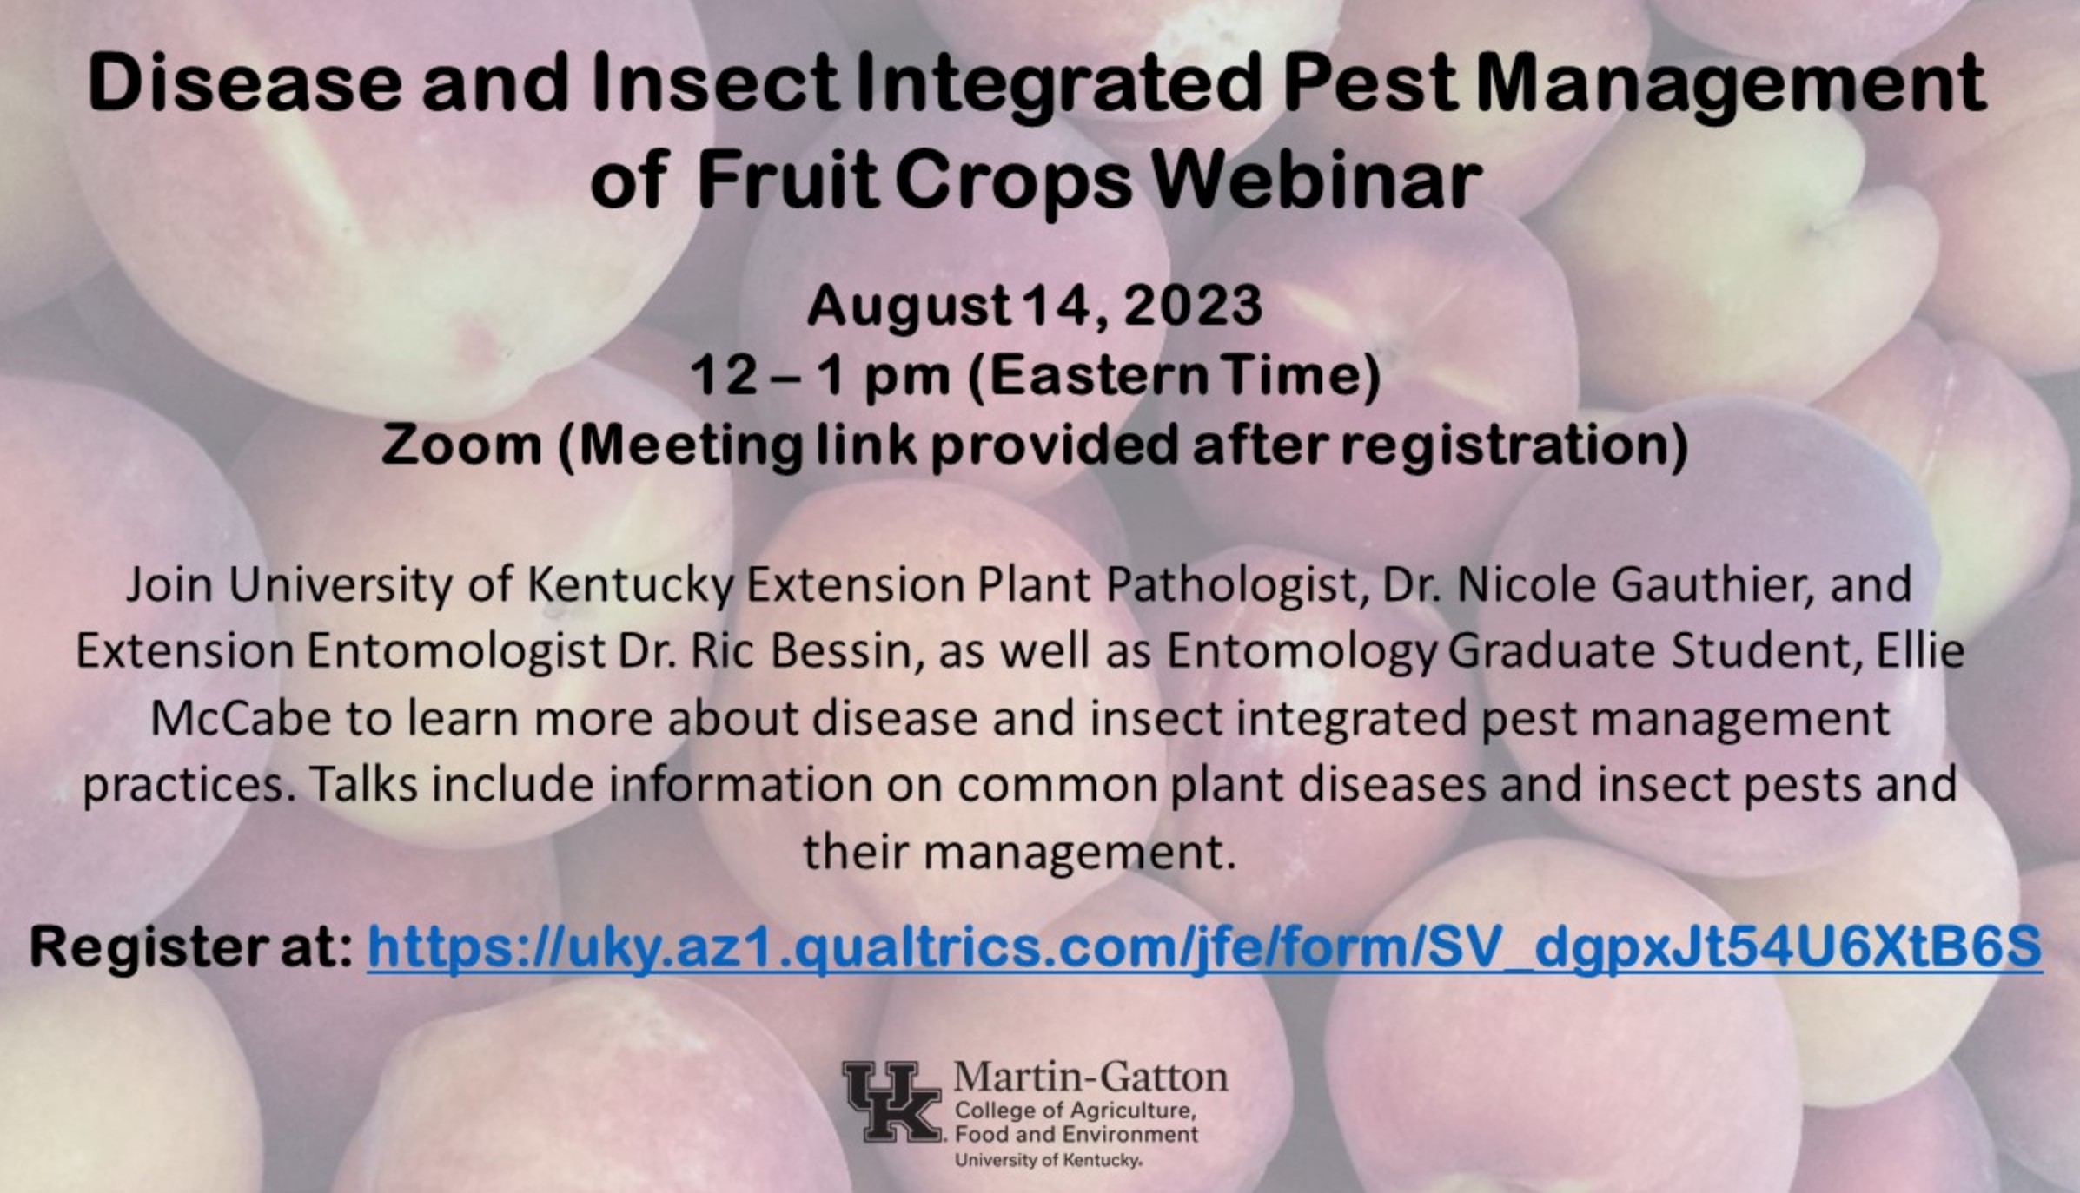


Make the most of summer fruits with this recipe!

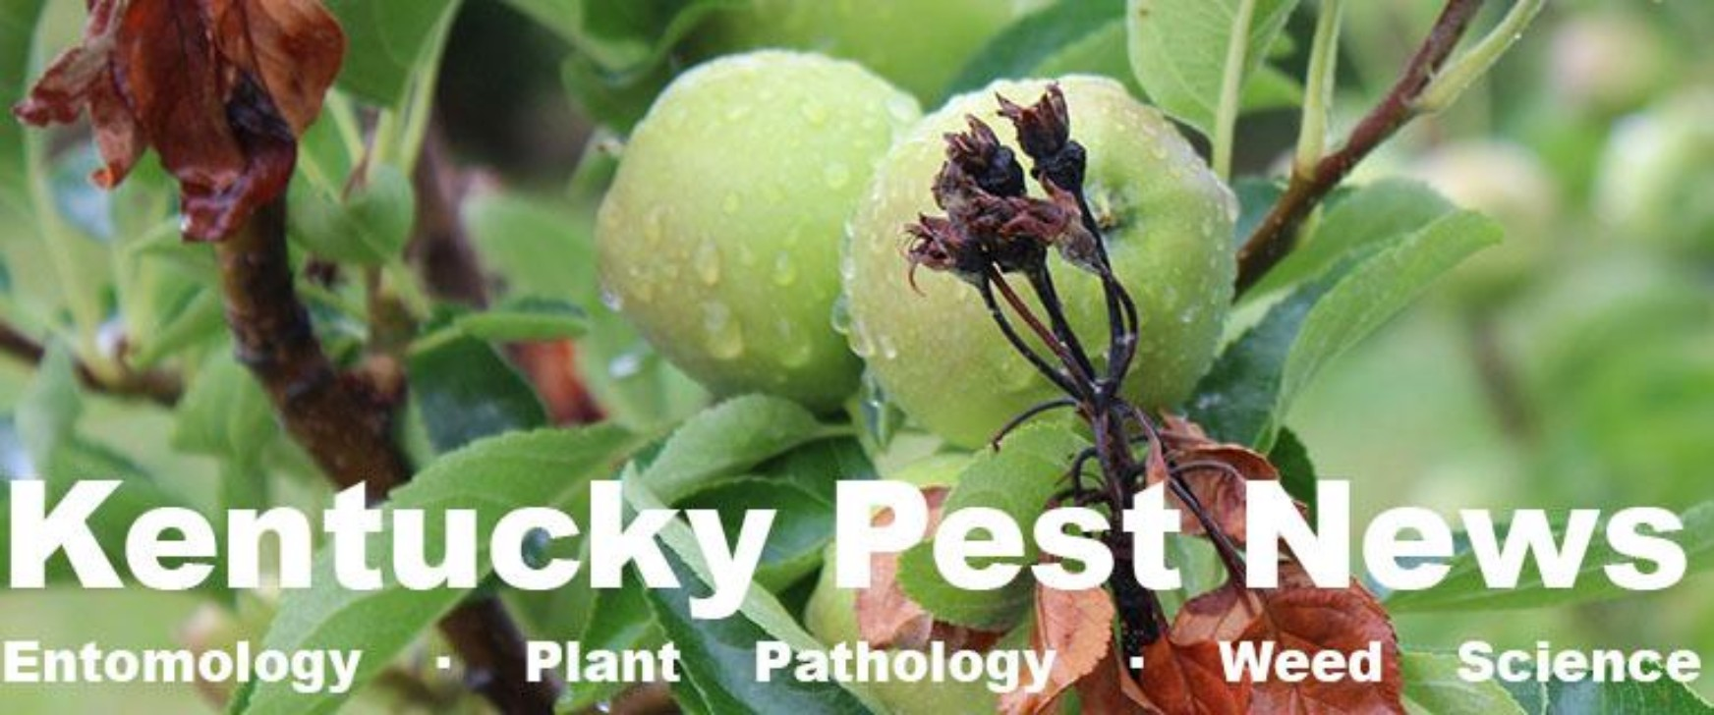
Do you want to stay on top of the latest pest issues in Kentucky? If so, you should subscribe to the Kentucky Pest News newsletter, brought to you by the University of Kentucky Extension Service. This newsletter is packed with useful information on insects, diseases, weeds, and wildlife that can affect your crops, gardens, and landscapes. You'll also get tips on how to manage these pests effectively and safely. Plus, you'll be the first to know about upcoming events, workshops, and webinars on pest management topics. Don't miss out on this valuable resource - sign up today and get Kentucky Pest News delivered to your inbox!
Web Link: bit.ly/3rJj4cf or scan code on right


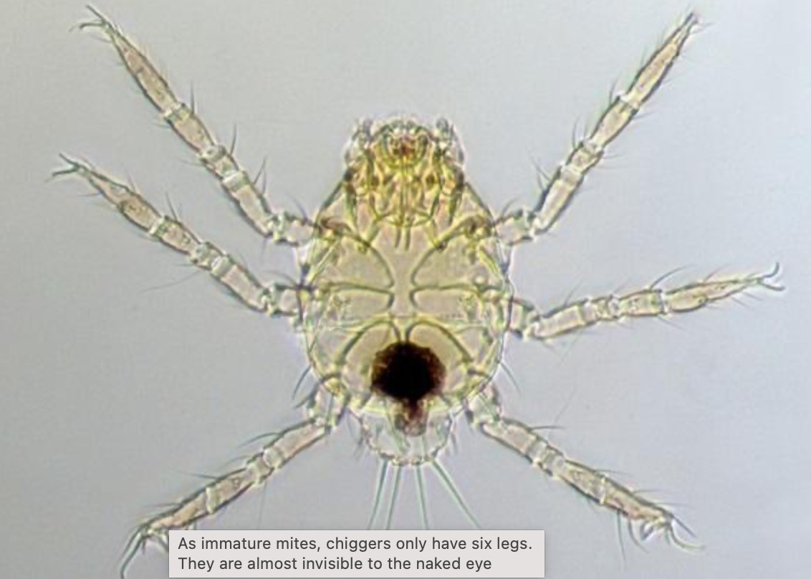
Chiggers are tiny mites that can cause a lot of discomfort for people who encounter them in the outdoors. They feed on the skin of animals and humans, injecting a digestive enzyme that dissolves the skin cells and causes an intense itching sensation. Chiggers are most active in the summer and fall, and they prefer to live in overgrown areas with tall grass, weeds, and brush. However, they can also be found in lawns, parks, and campsites where they can attach to unsuspecting hosts.

To prevent chigger bites, it is advisable to wear long pants and sleeves, and to apply repellents that
contain DEET (permethrin products are available for clothing). These repellents can also protect against other biting insects, such as mosquitoes and ticks. If chiggers are already on the skin, they can be removed by taking a hot shower and scrubbing with soap. To relieve the itching, over-the-counter medications such as hydrocortisone cream or antihistamines can be used. However, the symptoms may last for up to two weeks until the skin heals.

By following some simple precautions and treatments, chigger bites can be avoided or minimized. For more information about chiggers and how to deal with them, please refer to: https://entomology.ca.uky.edu/ef630

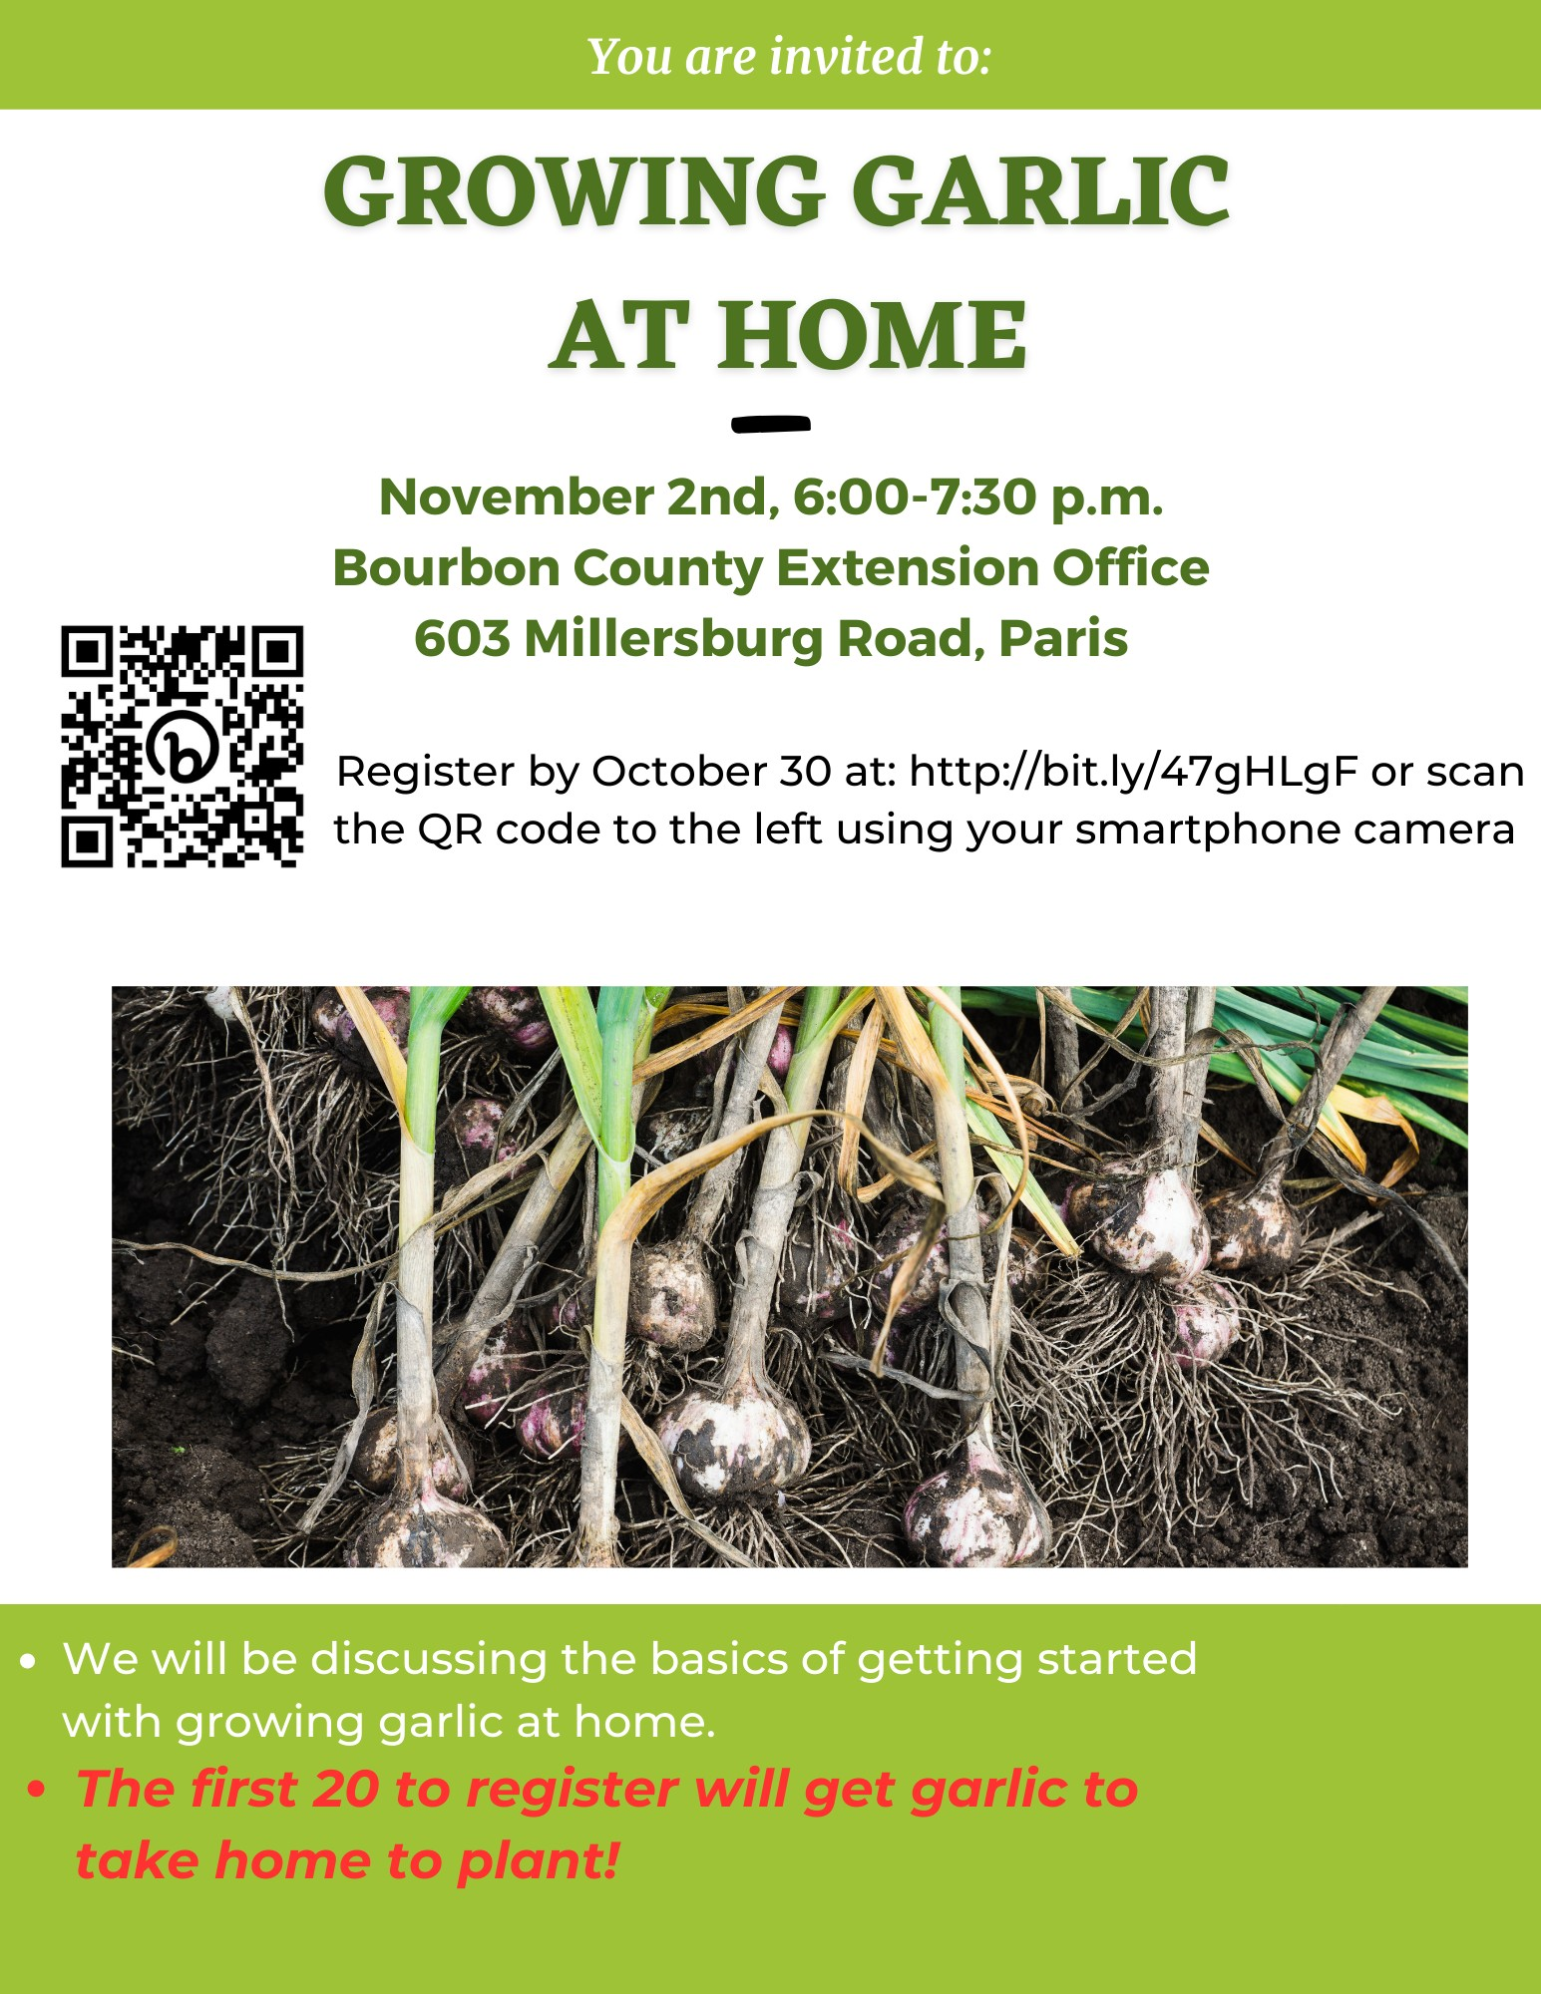

IF YOU ARE UNABLE TO SCAN THE QR CODE OR REGISTER ONLINE PLEASE CALL 859 987-1895

