
At the last meeting the homemaker council prepared a planned a calendar of the activities and events for 2023-24 homemaker year. A copy of this calendar of events will be included in this year’s yearbook and will be placed on the FCS website. Council members intentions are that everyone will have a guide for many of the exciting events planned for the coming year.
2023-24 is looking like the best year yet. Plan now to not miss out!

Kay Denniston
Bourbon County Extension Agent
For Family & Consumer Sciences

Dear Homemakers,
I would like to thank everyone who worked to make the 2023 Homemaker year a success. Everything from all the long hours that individuals put into volunteering at the homemaker events at the fair as well the making of items to exhibit. The Bourbon County Fair is an opportunity to spotlight all the talent, skills and dedication that is a part of the program. I cannot begin to estimate the number of hours put into this year’s fair.
We are started down the path of a new homemaker year which I anticipate being an exciting one. The Homemaker Council met to outline the coming year’s programs and I think you will be excited about what the year holds. Please remember if there is ever a program, project or subject that you would like to learn more about, reach out to me and I would love to try to work to make that happen.
Check the “Save the Dates” for opportunities for volunteering and enjoying community fellowship. Recipe for Life is this month, and the Ovarian Cancer Tea will be soon after. This tea is a great opportunity to introduce friends and community members to the organization as well as benefit an a good cause.
Be sure to sign up for officer and/or chairman training. The council chose to try something different and separate the two trainings to allow those that hold multiple positions to attend both. To encourage attendance and participation in both there will be a light meal served between the two trainings. Please call the office to reserve your spot – we want everyone to have plenty to eat.

August 2023

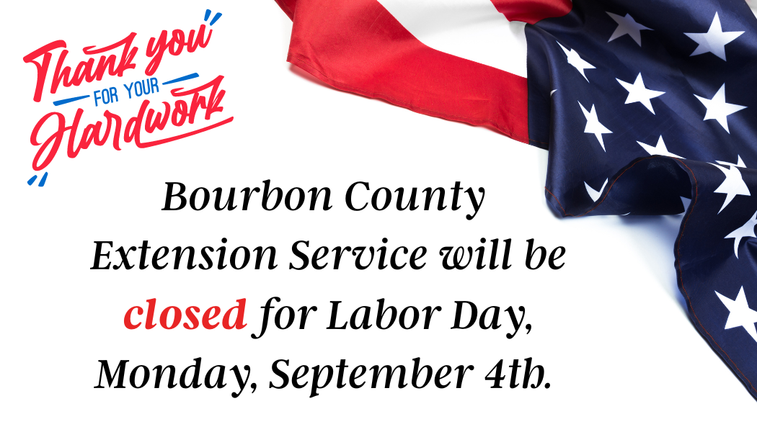


Breakfast Ideas to Try
The morning meal doesn't have to be all about normal breakfast items. You can mix it up to have other foods and still have a good healthful start to the day.
Serve a balanced breakfast that is made up of whole grains, protein, and fruit or vegetables. You could try any of these delicious ideas:
• whole-grain cereal with low-fat milk topped with fruit or nuts
• whole-grain waffles topped with peanut butter or ricotta cheese and fruit
• whole-wheat pita stuffed with sliced hard-cooked eggs and fresh spinach
• oatmeal topped with nuts and fruit and sprinkled with cinnamon
• half a whole-grain bagel topped with peanut butter and fresh fruit (banana or apple wedges)
• breakfast smoothie (low-fat milk or yogurt, fruit, and wheat germ or bran whirled in a blender)
• vegetable omelet with whole-wheat toast
• sliced cucumbers and hummus in a whole-wheat pita
• lean turkey and tomato on a toasted English muffin
• heated leftover rice with chopped apples, nuts, and cinnamon
• shredded cheese on a whole-wheat tortilla, folded in half, microwaved for 20 seconds and topped with salsa
Source: Adapted from https://kidshealth.org/en/parents/breakfast.htm

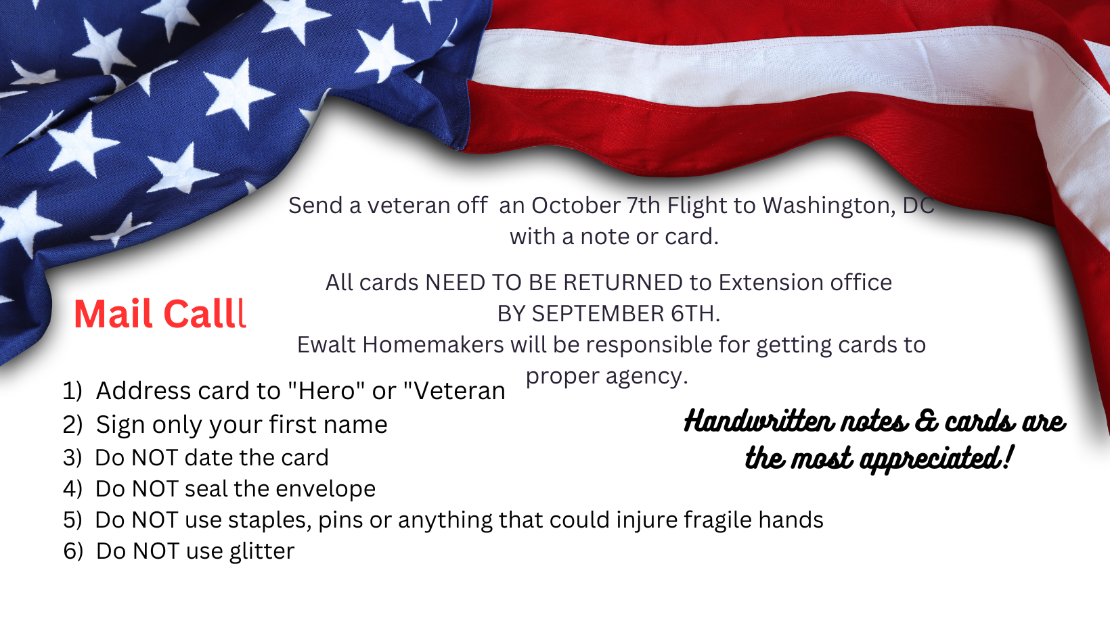



Save the Date

“OUTSIDE the BOX”

August 17-27……………..Kentucky State Fair
August 22……………..………..Leader Lesson
August 24………,,,,,,,,,,,……..Officer Training
August 24………,,,…..,,,,,,,,,……….Light Meal
August 24………...………….Chaiman Training
August 25…..………Recipe for Life Volunteer
Training
August 31………………..……..Recipe for Life
September 1……………………Recipe for Life
September 2………….POP Club/Farmers Mkt
September 4……..…Labor Day/Office Closed
September 11-15……....Kay in Providence RI
September 19…….…………….Leader Lesson
September 21…………….Ovarian Cancer Tea
October 13….…..Bluegrass Area Annual Mtg
October 19 …………...…………Leader Lesson
November 2………….…………..Holiday Foods

“Bourbon County Homemakers, let’s get started thinking outside the box!”

Another homemaker year has officially begun!
This truly is bittersweet for me as this is the last year of me being president. I have learned so much these last few years and cannot wait to see what this year has in store for me. We have many amazing things planned for this year and I am beyond excited!!

The first event is happening on August 31 and September 1 and it is my favorite event ever, Recipe for Life. Unfortunately (and fortunately), since I am having a baby then, I will not be able to attend, but I know Elizabeth Rankin would love any helping hands she can get! Other events to look forward to are: Ovarian Cancer Tea, Holiday Foods, Secretariat Festival, and so much more.

We are proving “we are better together”.
Good job Bourbon County Extension Homemakers!

Mallory Lowe
President Bourbon County
Extension Homemakers

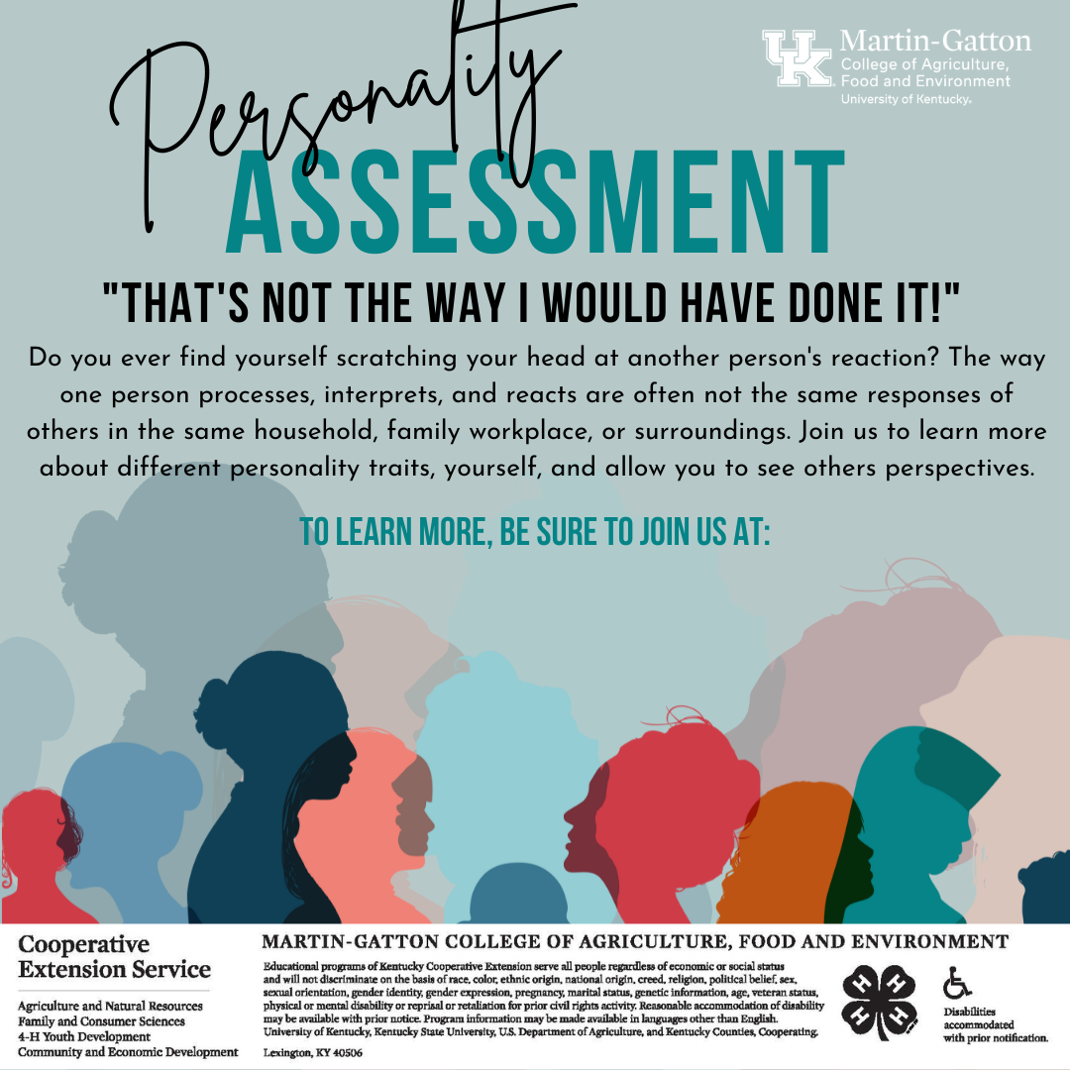

Coming to you on Bourbon County Nutrition Education Facebook page.
If you missed the 1st Friday, it is still available on FB and YouTube.

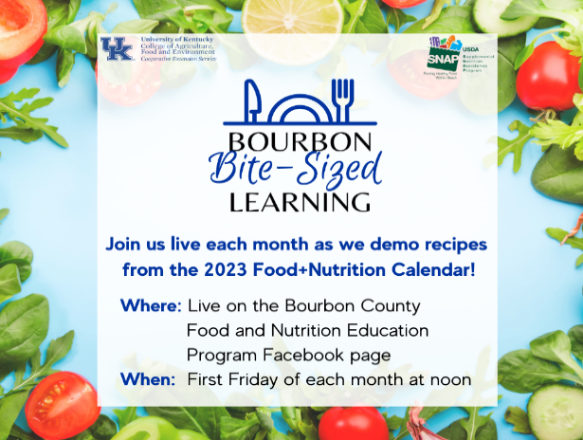
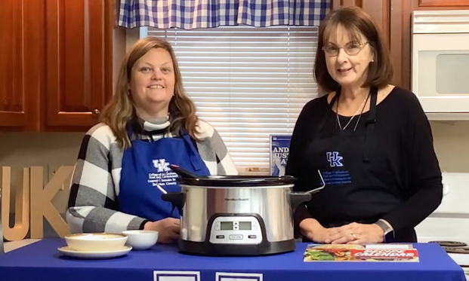
Stop
by the Extension Office
and pick up
your
2023
calendar
to cook
along!

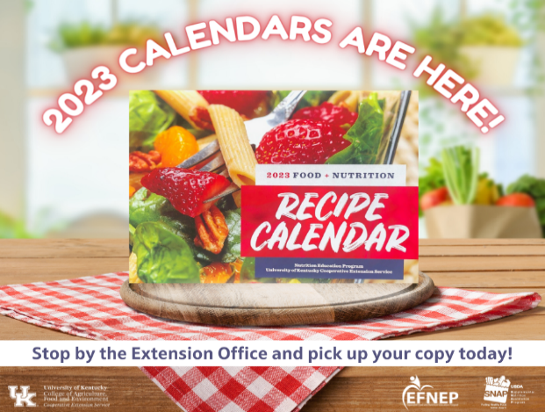
Join us on Bourbon County Nutrition Education Program Facebook page, September 1 to view Kay preparing “One Pan Shrimp and Veggies ” or even better - get your ingredients and prepare along with us. Mark your calendar September 1st at noon!



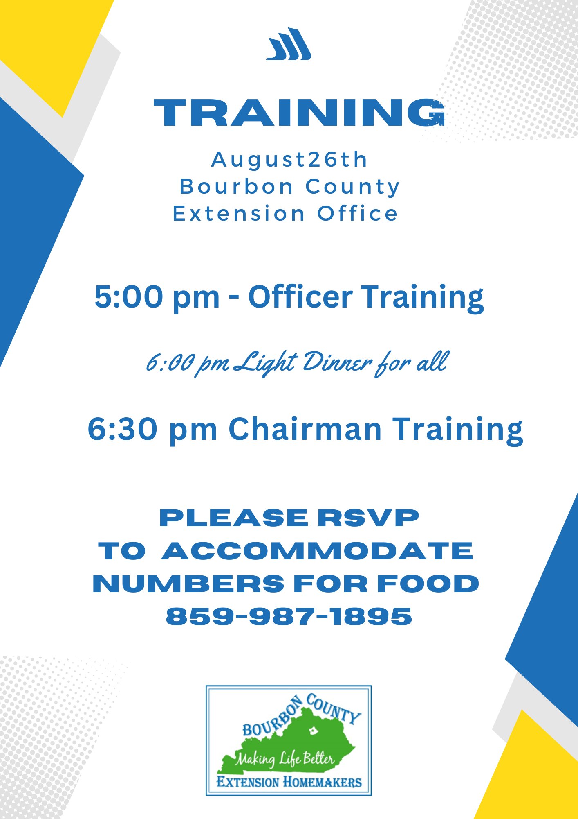

Dear Homemakers,
Awesome Homemakers! Thank you for an awesome job at the Bourbon County Fair Hospitality Tent this year. We had plenty of sandwich fixings and cookies. We received very nice compliments and donations which went to our scholarship fund account. We had a lot of new faces on the food line preparing all the goodies and greeting the horse show exhibitors and guests. I greatly appreciated all the help.
Again, thank you to all. Bourbon County Homemakers are the best!
Connie Vaughn
Connie Vaughn
Horse Show Hospitality Chair

Stay for dinner

Come early for dinner and stay for training.



Recipe for Life
It is that fun time of year when we have the opportunity to work with every 5th grade student in all of Bourbon County!

Mark your calendars for
Afternoon of AUGUST 31
Morning and afternoon of
SEPTEMBER 1

2023 Bourbon County Fair Dedication
The 2023 Bourbon County Fair was dedicated to the Bourbon County Extension Homemakers in honor of all the volunteering and support for the fair. Pictured is the plaque being presented on opening night of fair.

Back-to-School Breakfast Ideas
a

We often hear breakfast is the most important meal of the day. But why? Children who eat breakfast do better on tasks that require attention and higher-level brain functions. This means children who eat breakfast focus and concentrate better and have fewer behavior problems. They also have higher school attendance, fewer hunger-induced stomach aches, and better muscle coordination. Children who eat breakfast also tend to have an overall healthier diet.
It is easy to miss or forget breakfast during the rush to get out the door for school. But a little planning and prep will have your family fueled for whatever the day brings. Try one or more of these tips to help make breakfast part of a back-to-school routine that sets children up for success.
- Prep the night before. Set out breakfast options before going to bed. This will allow children and adults to easily get started eating or grab something for the road.
- Set the alarm a few minutes earlier. A few extra minutes in the morning can provide time for a quick breakfast. It can also provide time for children to wake up and feel hungry or ready to eat.
- Role model breakfast. Children copy adults’ behavior. Sitting down to eat with children or at least eating while getting ready shows them breakfast is part of the start of the day.
- Pack breakfast to go. Breakfast does not have to be eaten at home. You can pack healthy options for the bus or car ride to school and work.
- Try school breakfast. Many schools serve nutritious breakfast. Ask your school and encourage children to take advantage of this.
Eating something is better than nothing. But to fuel the body and brain for a day of academic, social, and physical activity, the standout combination is a whole grain, some protein, and either fruit or vegetables. Find whole grains in things like hot or cold cereal, bread, tortillas, muffins, waffles, or even leftover rice or pasta. Look for protein, which is often missing from breakfast, in dairy products, eggs, nuts and seeds, beans, or animal meats.
Try one of these quick, easy ideas to fuel children’s brains and behavior. Or create your own combination!
- Hot, instant cereal. Add protein by making it with milk instead of water. You can change up the flavor based on things you mix in. Want it sweet? Add fresh, dried, or even frozen fruit and nuts. Want it savory? Add cheese and an egg with veggies of your choice.
- Yogurt bowl. Start with a base of plain yogurt and then add fresh, canned, or frozen fruit and whole-grain cereal or granola.
- Egg sandwich. Have an egg your way with cheese and veggies of your choice on a whole-grain bread, bagel, English muffin, or pita.
- Smoothie. Blend milk, frozen fruit, and a banana. You can add yogurt or nut butter for more protein and flavor.
- Tortilla roll. Spread nut butter and your choice of fruit on a whole-grain tortilla. Roll up and enjoy.
- Cheese and whole-grain crackers. If you feel like snacking for breakfast, try veggies and hummus or fruit with whole-grain crackers and a stick or slice of cheese.
- Dinner for breakfast. Leftovers are another quick and easy option for breakfast.
For more ideas, visit the Extension office or the planeatmove.com/recipes website.
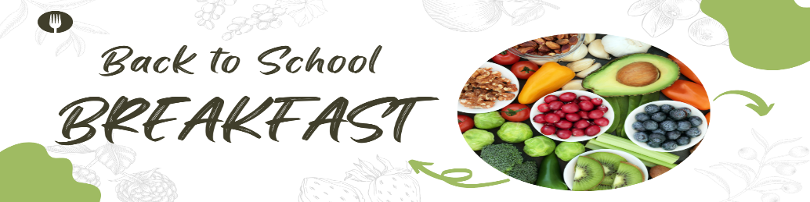
Summer Homemaker Fun!


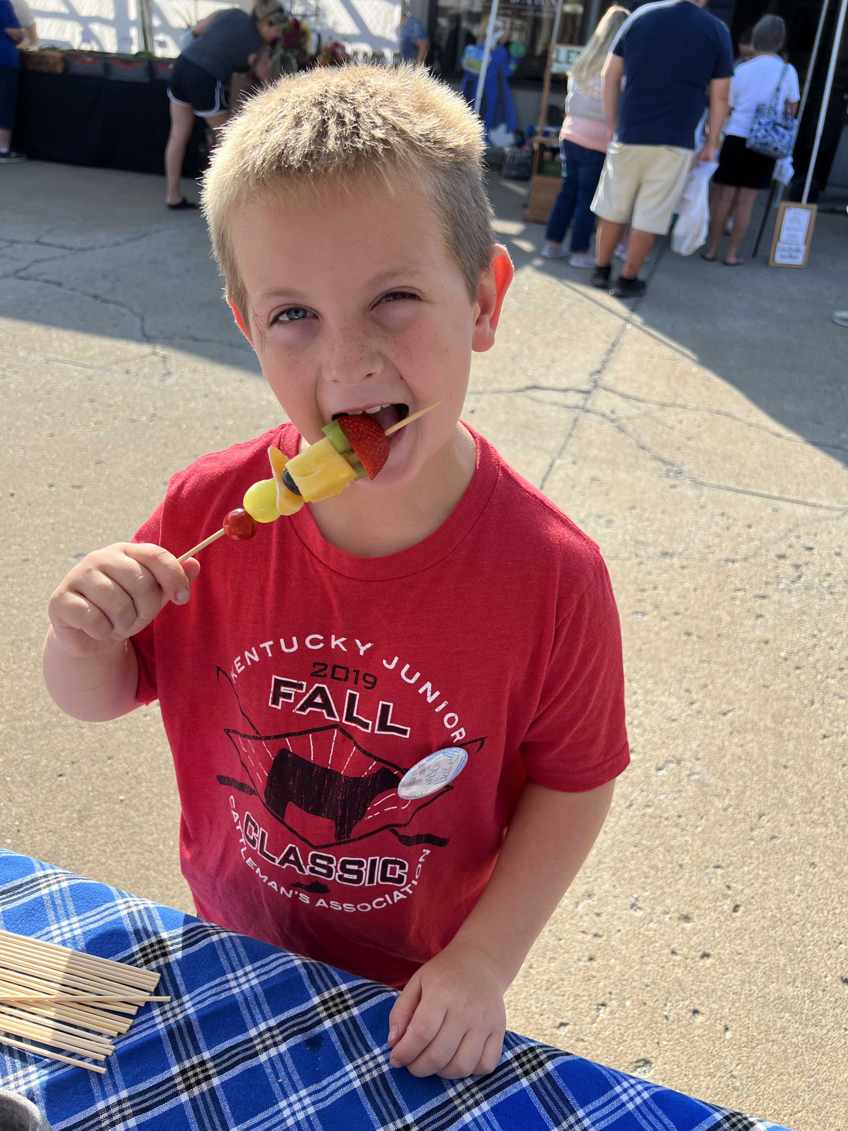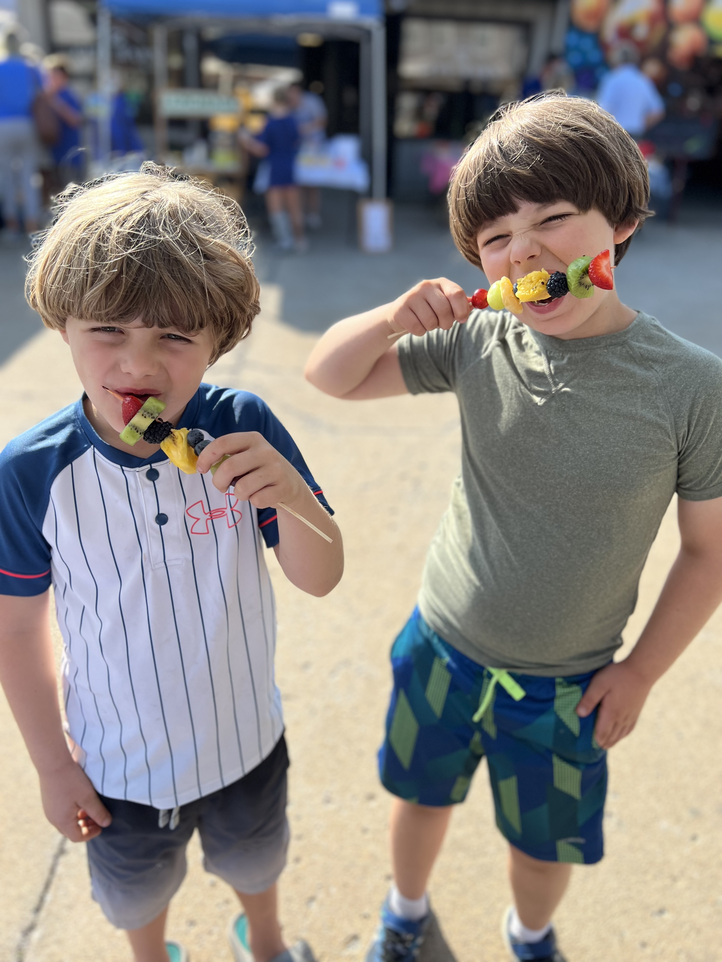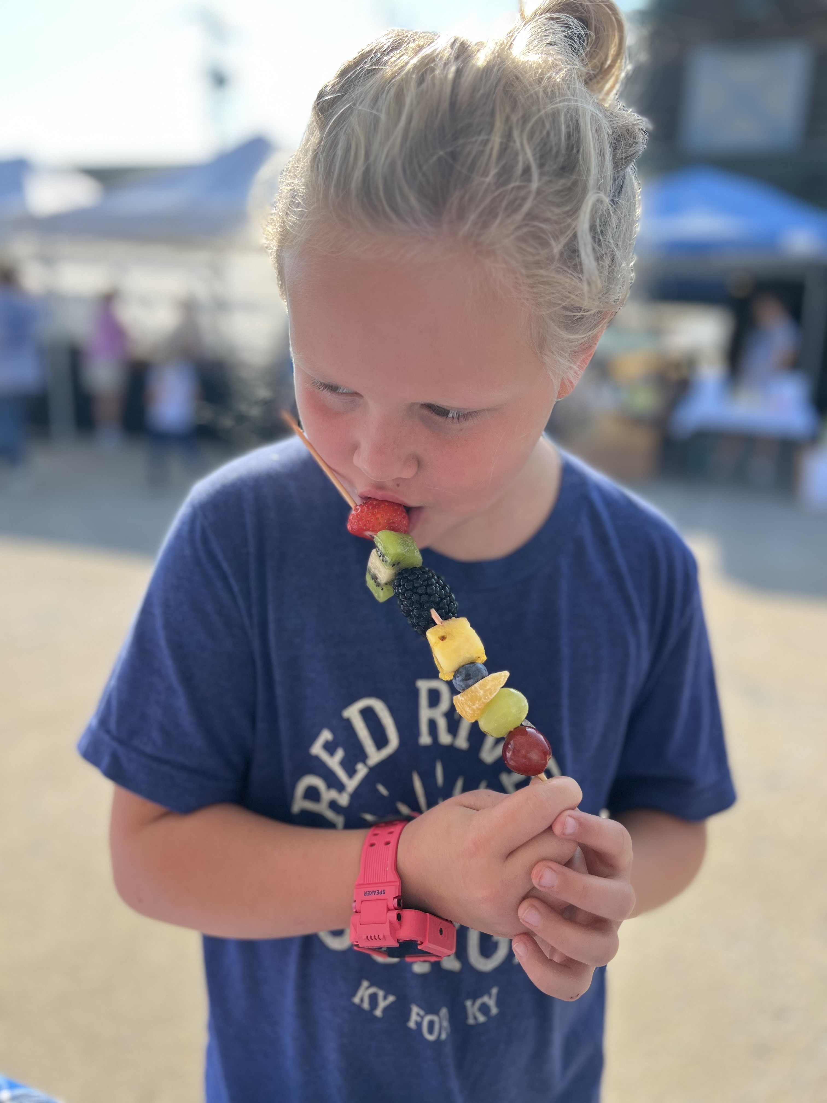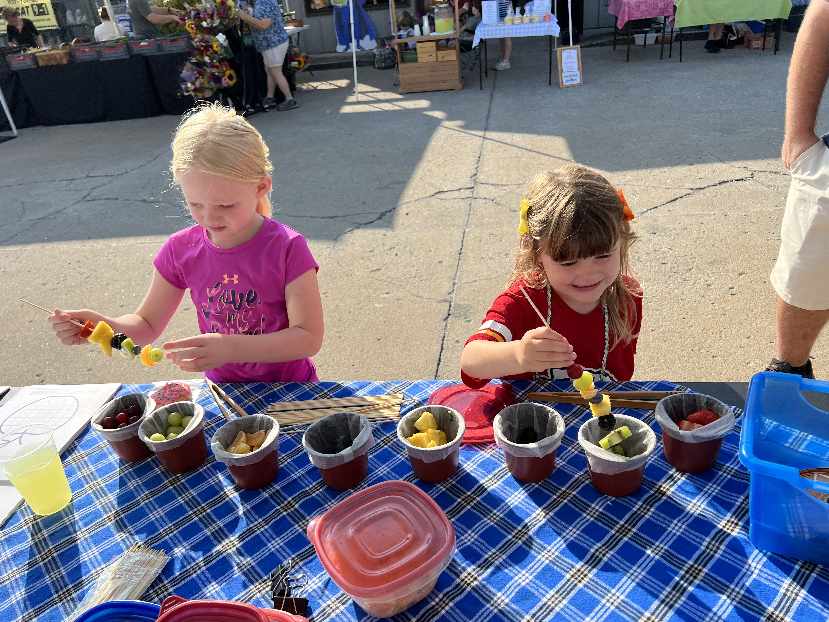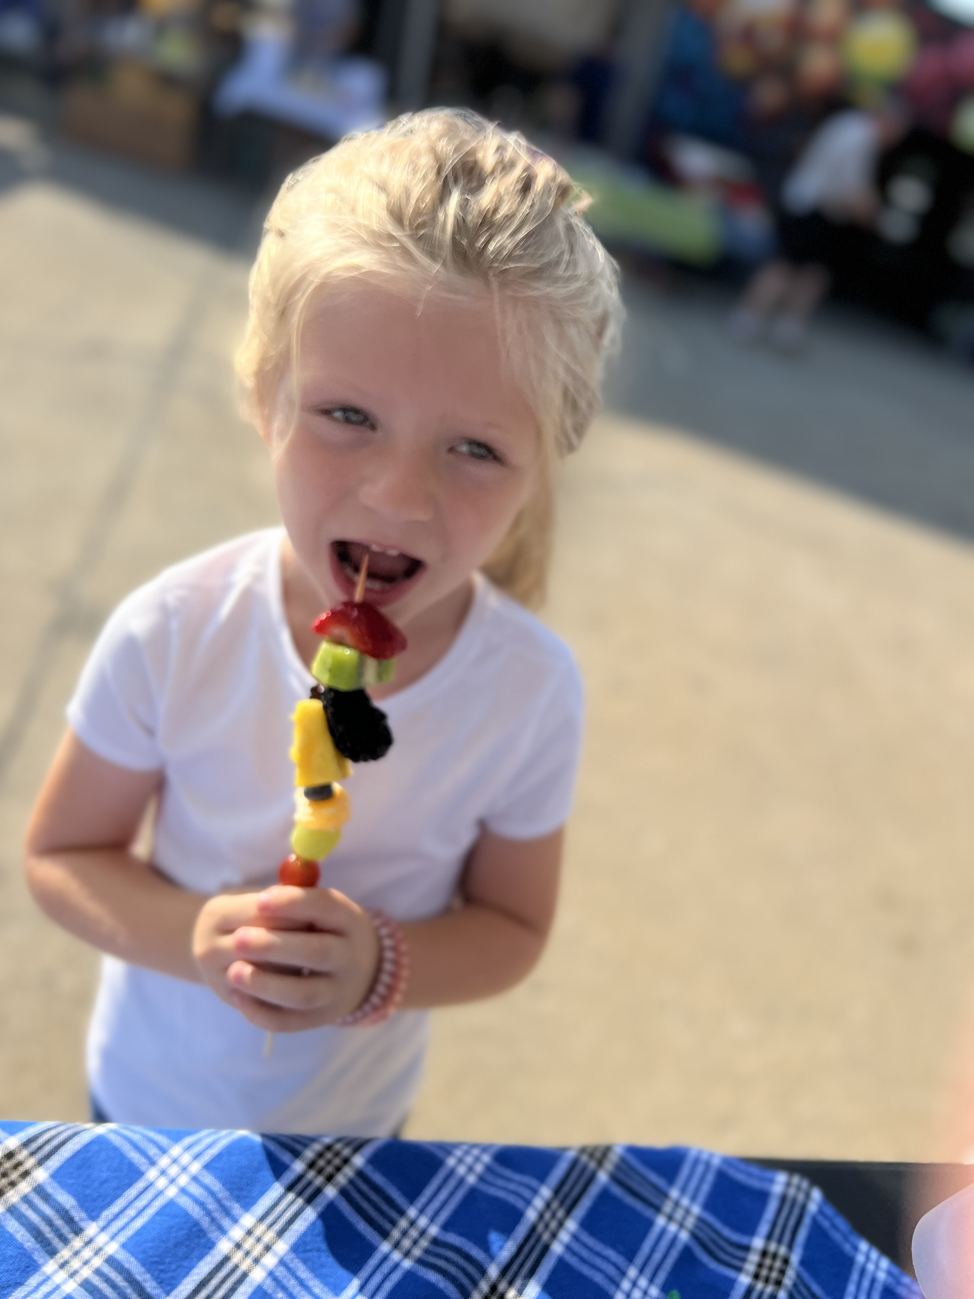

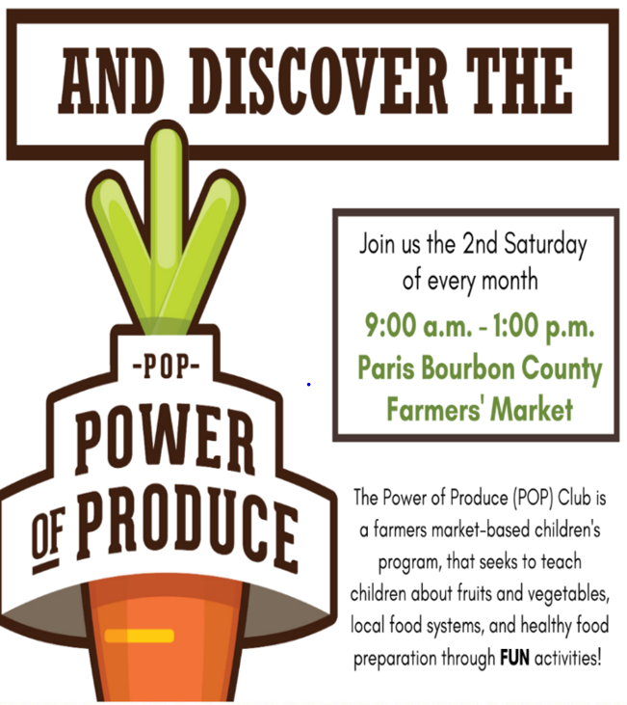

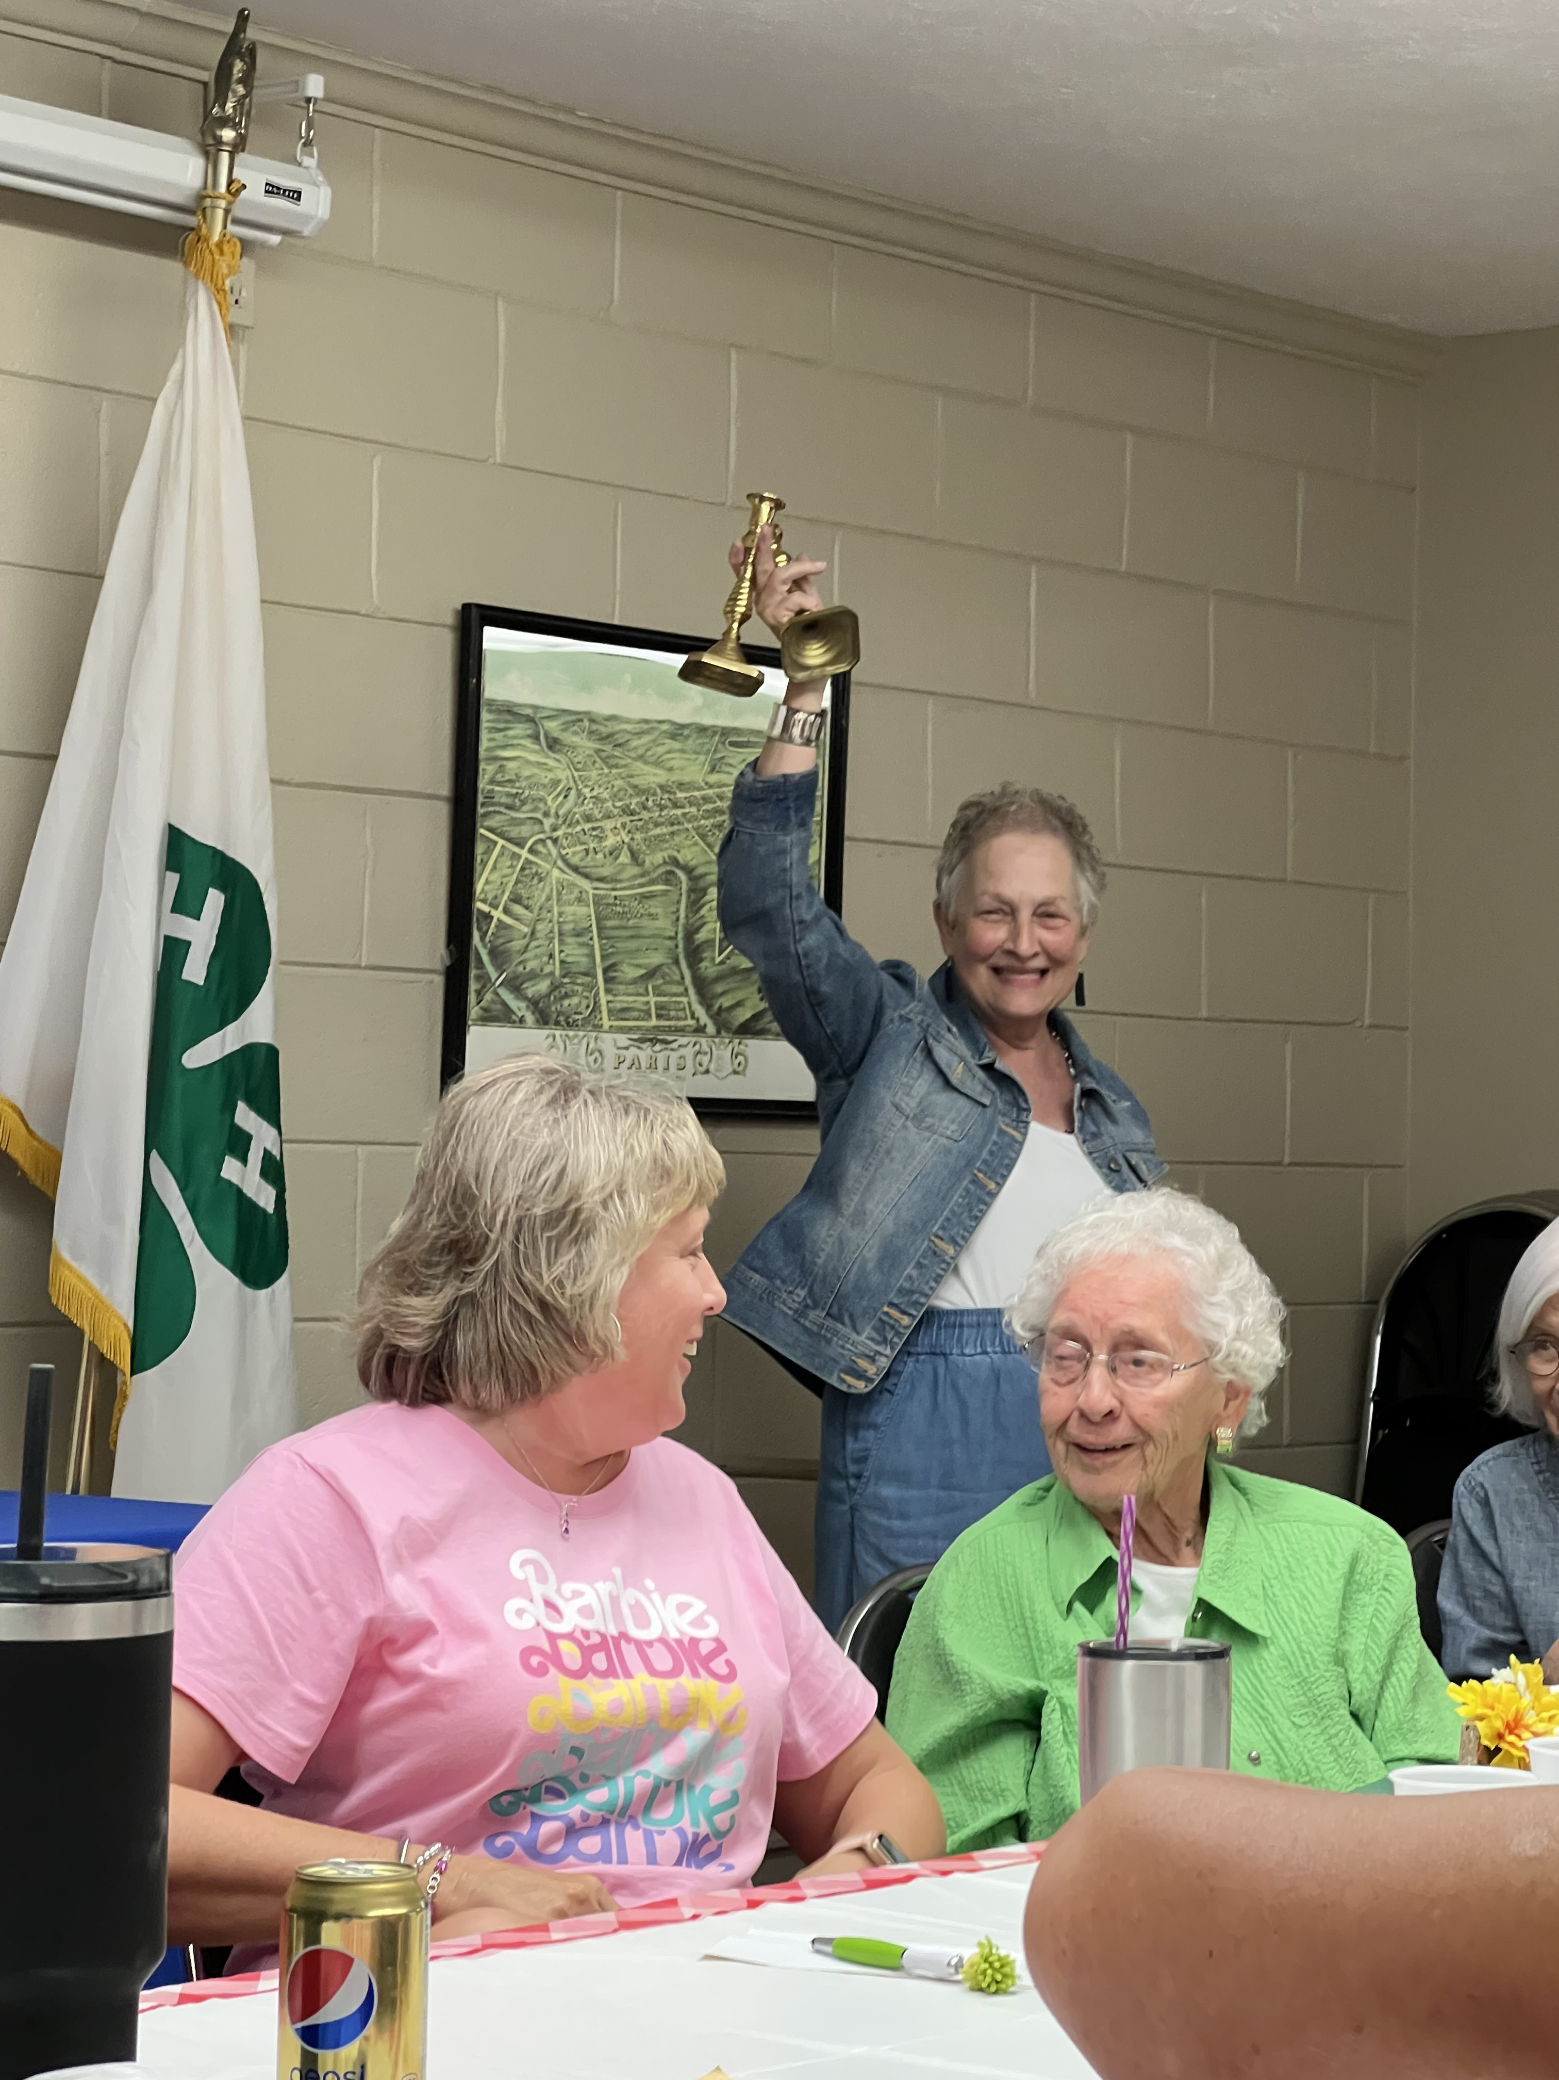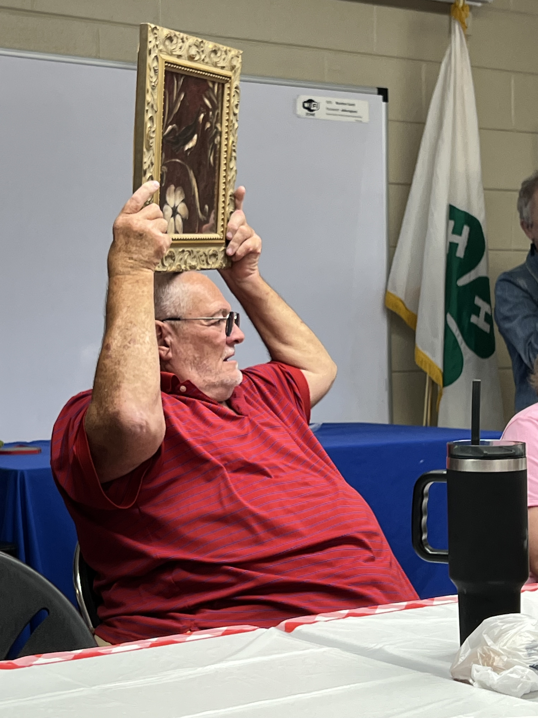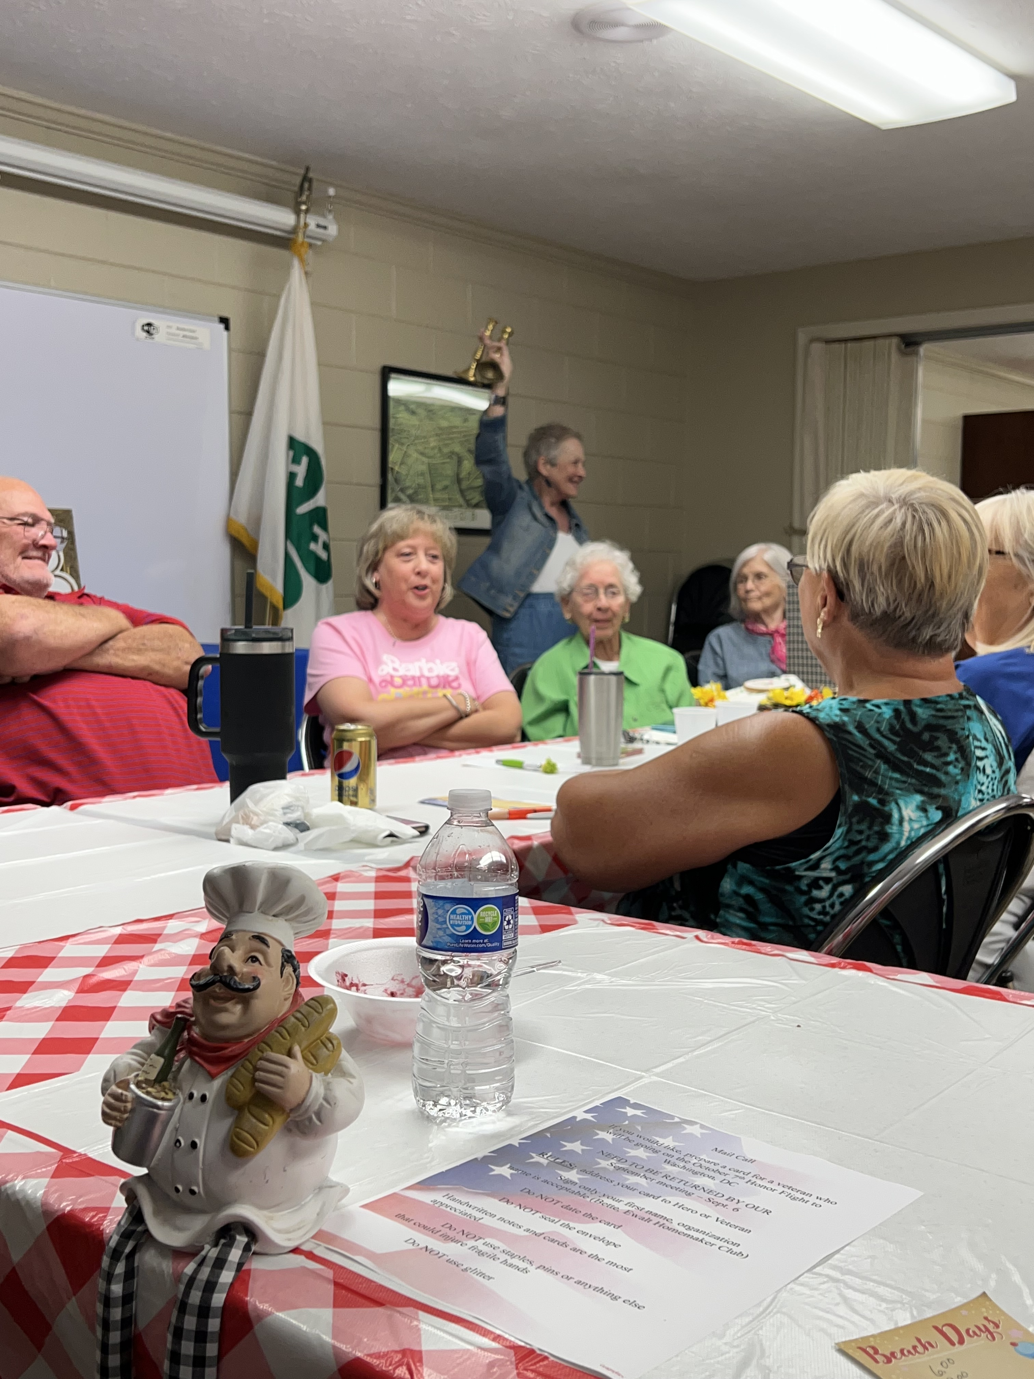

Ewalt Club Family Night

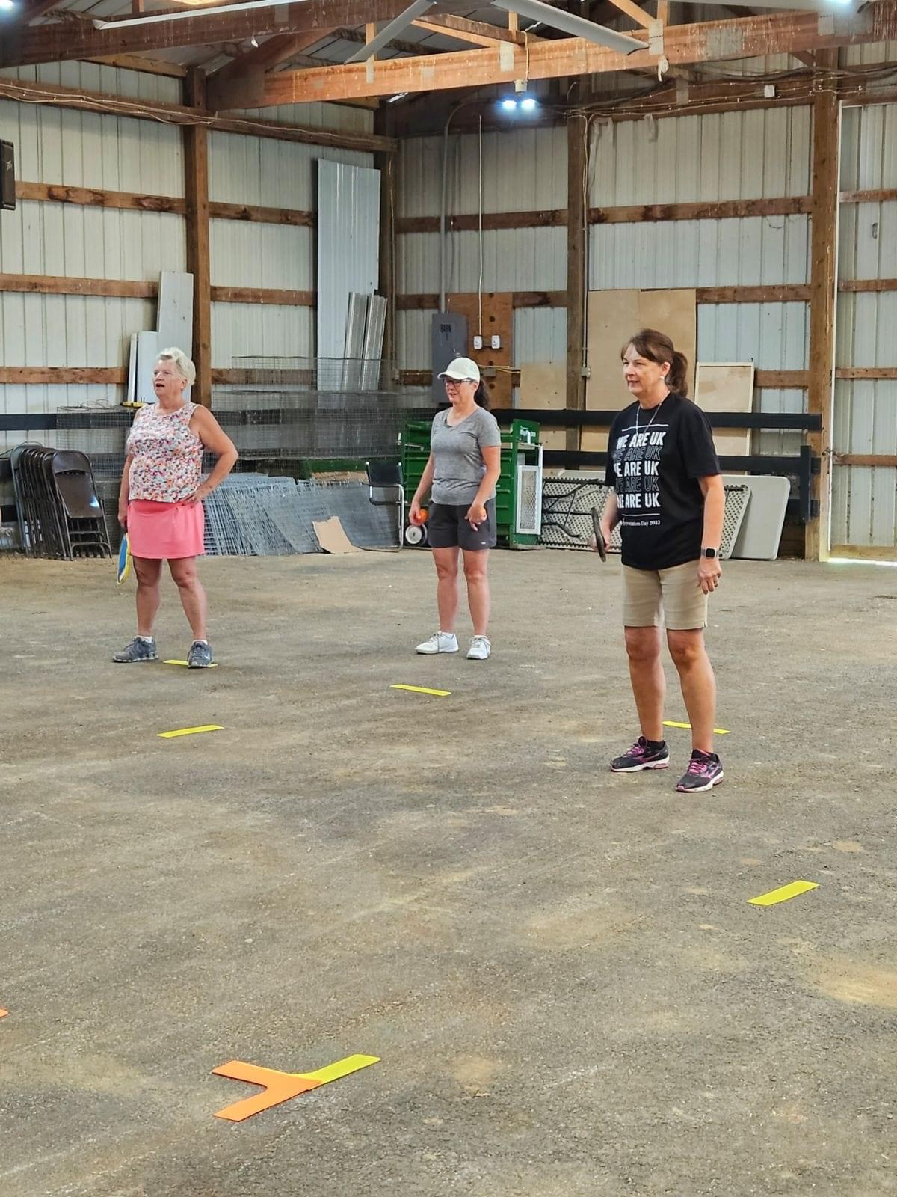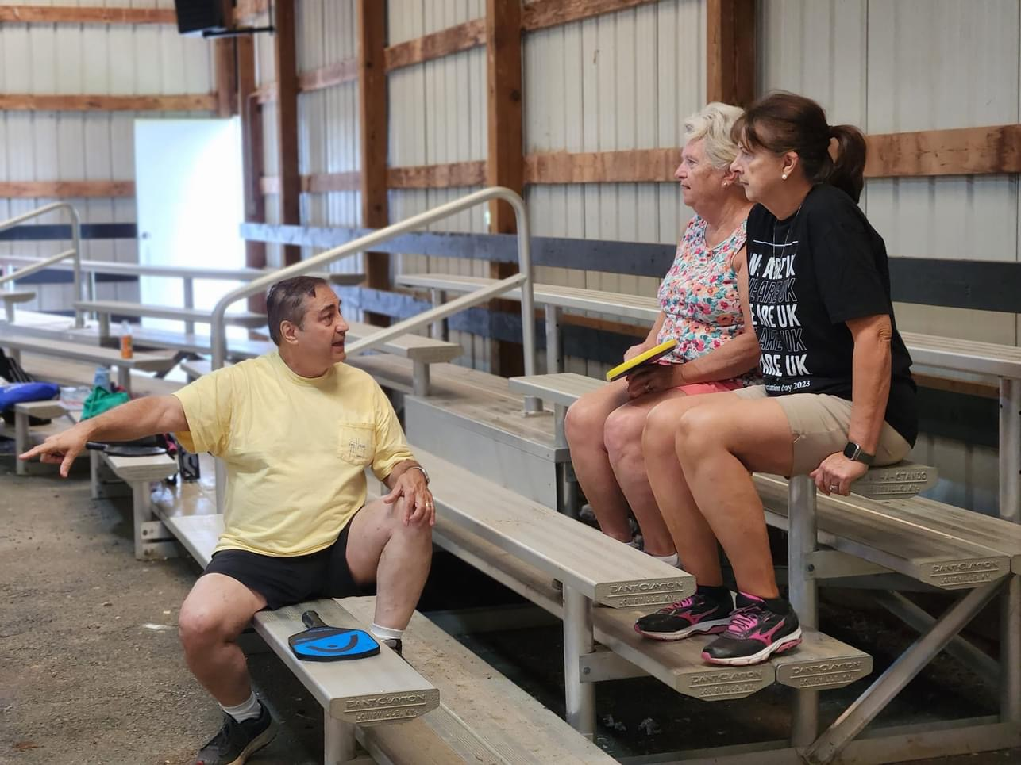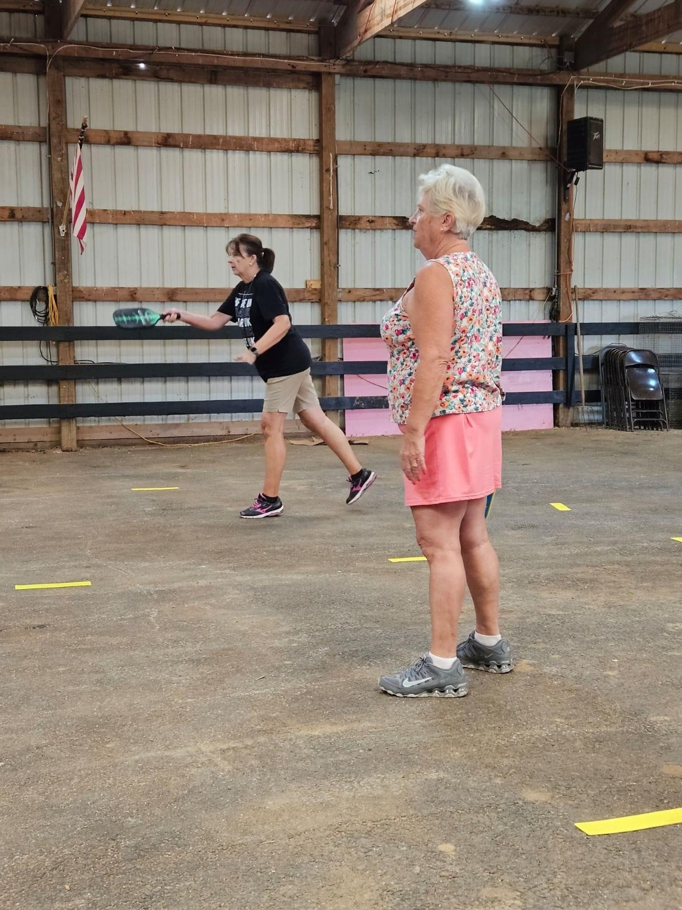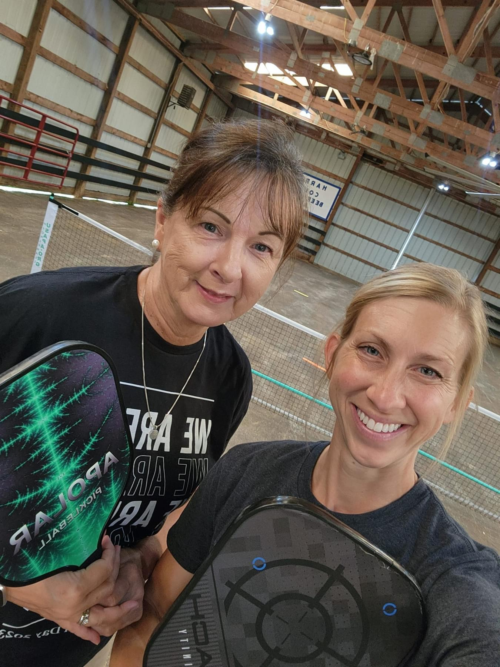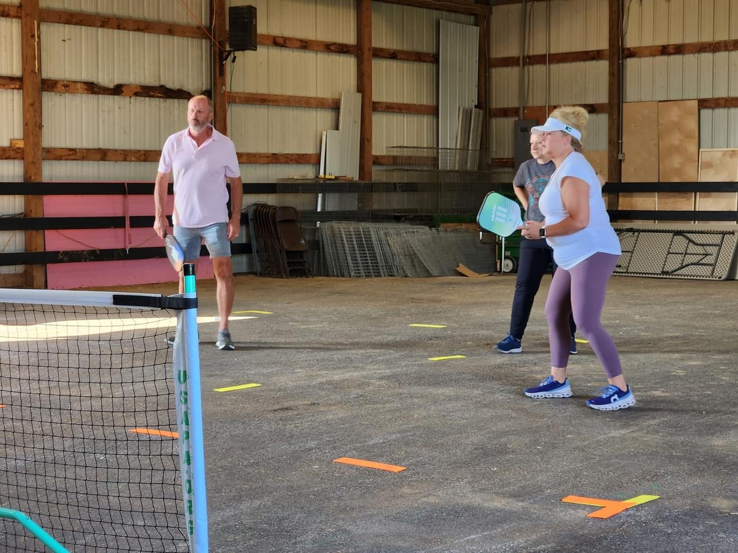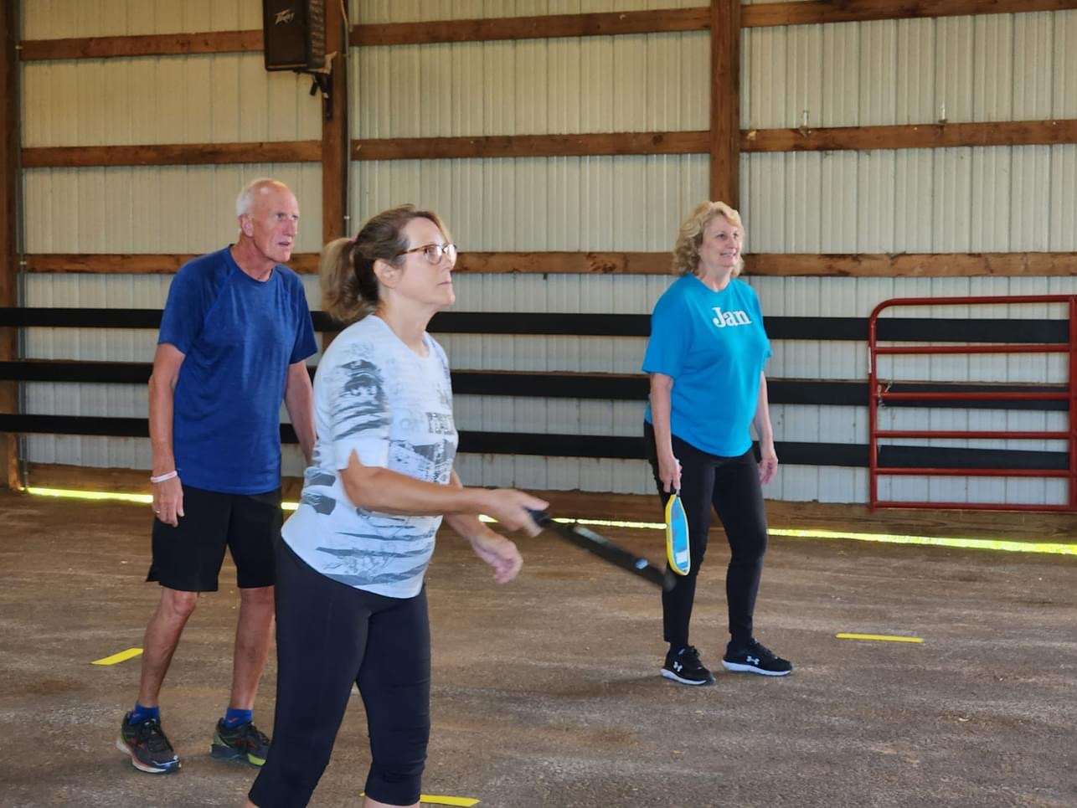

Pickleball

